The basic components of an effective communication:
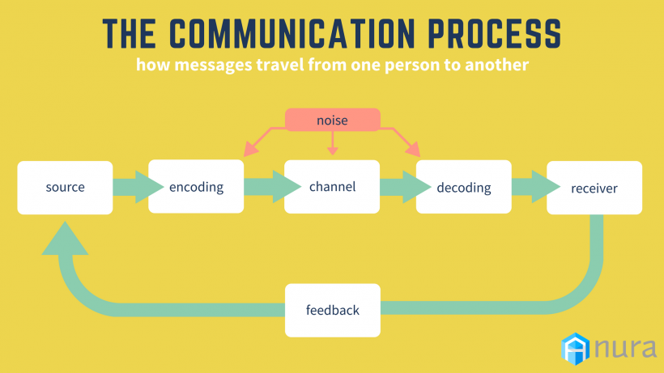

Source
The source, sometimes called the sender, is the person, organization, or other entity who sets the communication process in motion. Your primary responsibility as a source is to take whatever idea you have in your brain and package it into some type of meaningful message that people will understand.
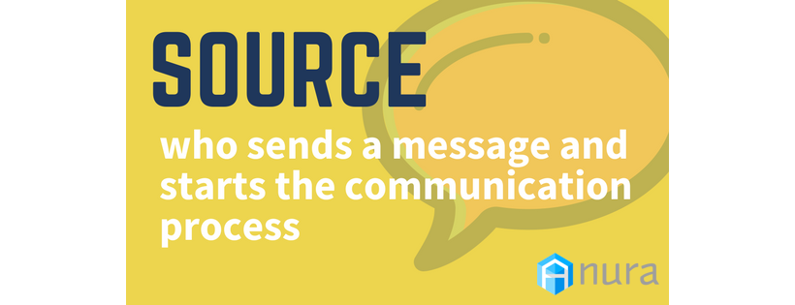
Everyone in the advertising and marketing world, from the sales team to the creative department, falls in this category. Think about it: advertisers want people to know about their products. Salespeople talk to leads. Content writers educate people about the company and industry. Without someone starting as a source, communication won’t happen.

Message
The whole communication process is about sending messages. A message is a primary idea or piece of information that passes from a source to a receiver. At the start, messages are more conceptual than anything. They’re your thoughts after a brainstorming session or sketches of a plan.
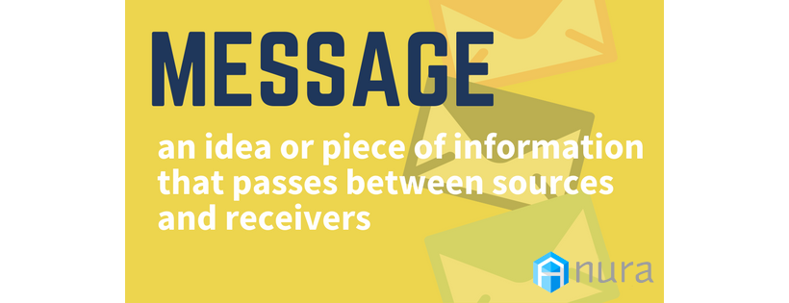
In our little marketing world, messages usually try to inform, entertain, alert, and persuade consumers about a product, service, or brand with the goal of closing a sale or building awareness.

Encoding
Once you come up with your main message, you need to make it concrete. Through encoding, you translate your idea into a tangible, deliverable form of expressions, such as written words or a speech.
For example, there are many ways to convey a farewell message. You can say, “Goodbye" or, “See you later!" Waving your hand left and right is a nonverbal method. Most people understand that texting the open hand emoji (?) symbolizes the same nonverbal message.
As advertisers and marketers, you have to keep your target consumer in mind when encoding your messages. Do more people respond to your blog posts, or have you found that infographics have a farther reach? Choose an encoding format that will engage your intended audience to maximize message effectiveness.

Noise
Did you ever play the telephone game as a kid? If your games were anything like mine, “My cat has fleas" somehow turned to “Matt eats bees" by the time it reached the last player.
Many times, messages run into similar problems through the encoding, channel, and decoding stages on their journey to the receiver. They can be disrupted, delayed, or distorted by outside forces, known as noise.
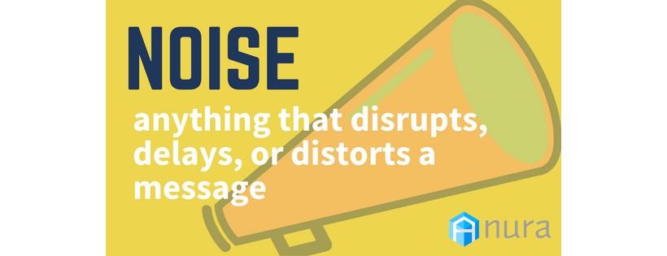
Whenever you launch an ad campaign or post a new piece of content, you’re competing with a whole range of other media. There are other ads, blogs, customer reviews, influencer posts... the list goes on and on.
Because there’s so much noise out there that might warp your message, you should always choose the appropriate channel to keep your ideas intact.

Channel
Communication channels span across all media, from print (magazines, newspapers), to broadcast (television, radio), to digital (social networks, apps). Even physical functions like voice and body language count as channels.
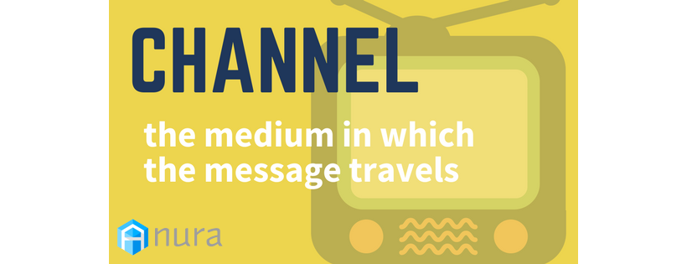
With so many options, you need to “tune in" where the customers are (bad pun, I know). No matter if you do your advertising online or IRL, research your audience demographics and logically place your messages where your targets will most likely interact with them.

Decoding
Once the message actually gets to the receiver, it’s their job to decode it. Decoding is the process in which the receiver interprets the message. When a message is clearly articulated, receivers should be able to decode it with ease.
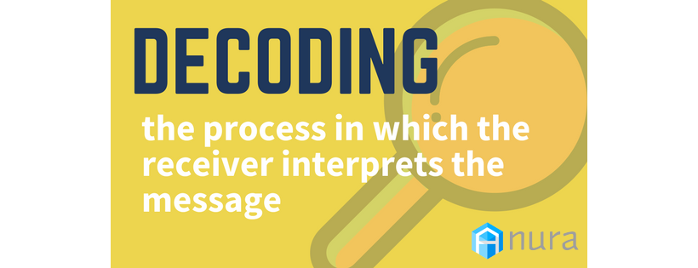
However, messages can be misinterpreted by a variety of factors. Differences like age, culture, ethnicity, and gender all shape people’s perspectives, and in turn, how they decode messages.

Receiver
If you didn’t figure it out by now, the receiver is the intended target for a message. They’re the blog readers, audience members, social media users, and customers you’re trying to reach at the end of the conversation.
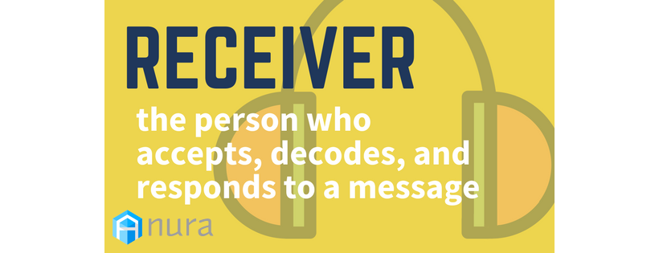
For most marketing and advertising communications, there’s no singular receiver. Rather, because so many people actually look at your campaigns, you could potentially be dealing with hundreds, if not thousands of receivers at once.

Feedback
Before the whole process begins again, receivers initiate the last stage: feedback. Here, they respond, directly or indirectly, to the source’s message. The quality of their feedback depends on the success of the decoding stage.
Feedback can take on numerous forms. Consumers may buy a product after seeing an ad. They might tweet at a brand or write a review on their blog. Most social media platforms, like Facebook and Instagram, let you see feedback in real-time; people can like and comment on posts seconds after they go live.
Some feedback isn’t so obvious. Metrics like click-through rates, impressions, and time spent on page show other ways in which receivers interact with your messages.

Breaking It Down
I get it: the formal communication process seems like an overly complicated way to explain really basic ideas. If you’re a little lost, here’s a simple example. Consider this nonverbal exchange between Jimmy and Lauren at school:
- Source: Jimmy is in class. He needs homework help.
- Message: He wants to ask Lauren about last night’s homework.
- Encoding: Since the teacher is talking, Jimmy decides to write a note.
- Channel: Jimmy writes the note on a piece of paper and hands it to Lauren.
- Noise: Other students are whispering; Lauren is trying to pay attention to the teacher.
- Decoding: Lauren reads Jimmy’s note and concludes he wants to copy her work.
- Receiver: Lauren is the note’s recipient.
- Feedback: Lauren writes “NO" on the paper and hands it back to Jimmy. He is sad.
If you ever find yourself asking why people aren’t reacting to your campaigns or posts, refer to the communication process. Understanding what takes place at each stage can help you pinpoint problems in your messages and improve your audience engagement in the future.
- Our Story
- Advertisers
  - AdPad
  - Sign Up for AdPad
  - Login to AdPad
- Publishers
  - Traffic Advisors
  - Sign Up for Traffic Advisors
  - Login to Traffic Advisors
- Blog
Contact Us

