Application Letters Types.
There are 3 different types of an application letters:
- Job Application Letter
A letter of application, also known as a cover letter, is a document sent with your resume to provide additional information about your skills and experience to an employer. Your letter of application is intended to provide detailed information on why you are an ideal candidate for the job.
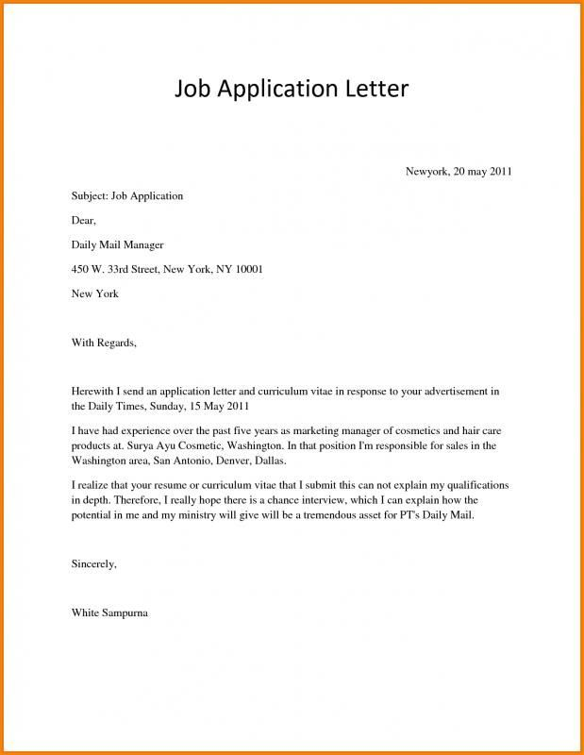
- Academic Application Letter
An academic cover letter describes your experiences and interest as a candidate for a specific position. It introduces you to the hiring committee and demonstrates how your academic background fits with the description of the position.
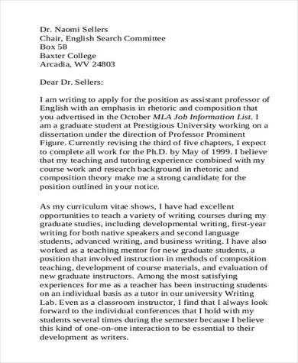

- Personal Application Letter
A personal letter is a type of letter (or informal composition) that usually concerns personal matters (rather than professional concerns) and is sent from one individual to another. It's longer than a dashed-off note or invitation and is
often handwritten and sent through the mail.

