Lecture 5+6: Introduction to Verbs

Verbs: A verb is a word that describes the state of a person or what he does.
Classes of Verbs
Verbs are classified into two categories; main verbs and auxiliary verbs.

1. Main (Lexical) Verbs
Main verbs occur independently in a sentence and convey the complete meaning of the action.
E.g., run, eat, think
Most lexical verbs have regular endings for forming past and present tense.
However, many of the most common lexical verbs in English have irregular
morphologies.

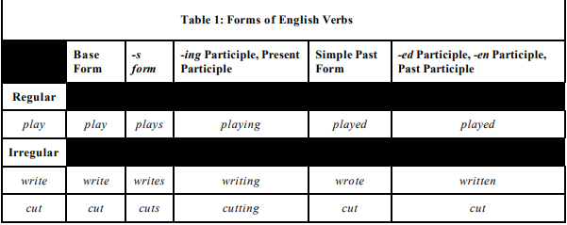
2. Auxiliary Verbs
Auxiliary verbs occur before a main verb and qualify the meaning of the main
verb. In other words, they occur along with the main verbs and indicate tense,
aspect, voice, mood of the speaker.
E.g., I w rote a letter. (main verb) I was writing a letter. (aux+main verb)
Note: Tense (Past, present, future) Aspect (Simple, progressive, perfect, perfect
progressive)
Voice (active and passive) Mood (Indicative, imperative, subjunctive)
Type of Auxiliary verbs
- Primary Auxiliaries: They are aux that can function as both auxiliary

and main
E.g., We are waiting for a bus. We are at the bus stop.
I h ave thought about it. I have a suggestion.
Does Tina need any help? Tina does all the work
- Modal Auxiliaries: They function only as auxiliary verbs. Modal
auxiliaries are can,could, may, might, must, ought to, shall, should, will,
would. They help other verbs, but unlike do, be, and have, they have their
own meanings.

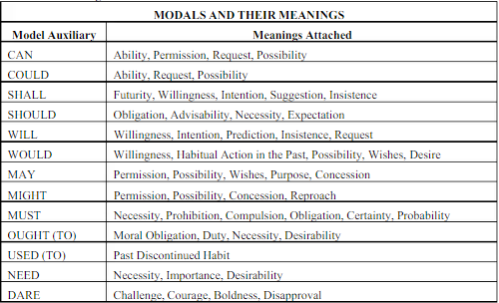

Forms and Patterns
1. Negatives and Auxiliary Verbs
To make a negative, add not to the auxiliary verb. If there is no auxiliary verb, use do not/ does not/ did not.
It is possible to contract the auxiliaries and use the uncontracted not.
E.g., He's not playing today. = He isn’t playing today.
I've not read that book yet. = I haven't read the book yet.

2. Questions and Auxiliary Verbs
To make a question, invert the subject and the auxiliary verb. If there is no
auxiliary verb, use do/does/did.
E.g., She’s wearing jeans. Is she wearing jeans? / What is she wearing?
I know you? Do I know you?
He wants an ice-cream. Does he want an ice-cream? / What does he want?
There is usually no do/does/did in subject questions
E.g., Who wants ice-cream? Who broke the window?

3. Short Answers and Auxiliary Verbs
Yes/No questions should be answered by yes or no and the auxiliary only.
The original subject, if a noun, is replaced by a pronoun.
E.g., Should he have gone? Yes, he should. Did the twins go? Yes, they did
4. Agreement and Disagreement with Remarks
4.a. With Affirmative Aux
Agreements with affirmative remarks are made with yes/so/of course +
affirmative auxiliary.
If there is an auxiliary in the first verb this is repeated. If there is no
auxiliary do, does or did is used.
E.g., He works too hard. ~ Yes, he does.
Bread won't make me fat. ~ Yes, it will.
4.b. With Negative Aux
Agreements with negative remarks are made with no + negative auxiliary.
E.g., It wouldn't take long to get there. ~ No, it wouldn't.
You were born in Edinburgh. Were you born in Edinburgh? / Where were you born?

