
Mohammed Seddik Benyahia University JIJEL
Name: .........................................
Surname:.....................................
Group:.........................................
Sec:..............................................

Faculty of science and technology
Department of architecture and city ​​management
Licence degree

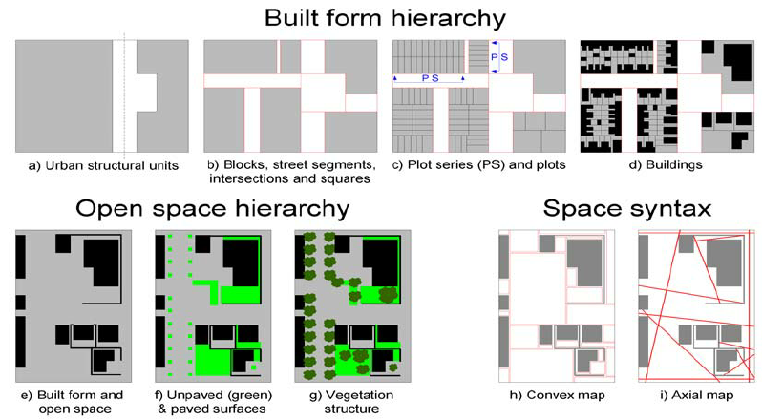
Frameworks for describing and classifying urban form are innumerable - every local town plan or urban design guide plays this role. Invariably such instruments conflate descriptive morphological factors with explanatory land use or functional criteria. More focused taxonomies have been devised for particular classes of urban elements such as streets, utilities and building stocks. Such specific-purpose frameworks can help inform a more universal descriptive scheme, but they lack the generality to order urban form from 'room to region'.
A viable classification framework to support morphological analysis in the broadest sense of 'city as
human habitat' (Moudon, 1997) must be comprehensive, consistent, coherent and transferable if it is to have value beyond the idiosyncratic. Consideration of the multiple scales of investigation, implying multiple levels of resolution, is a logical starting point. Similarly, multiple types of investigation must be accommodated within a single system boundary.
The urban structural unit, (USU), originally devised to facilitate evaluation of urban metabolism
(Pauleit & Duhme, 1998), offers the basis for such a framework. USUs are broadly defined as areas of relative homogeneity with respect to the type, density and arrangement of built form and open space, which delineate distinct configurations of the built environment. Each discrete domain - form and space - can be subdivided hierarchically in terms of the part-to-whole relations of its constituent elements (Kropf, 1993; Osmond, 2010), according to the scale and type of investigation. For example, a life cycle assessment may focus on construction materials, while a hydrological study will be more concerned with the extent of paved and unpaved surfaces.
Space syntax offers a third way to decompose the USU: into its convex and axial representations. The space syntax description of the configurational properties of the street network complements the morphological definition of streets in terms of segments, intersections and squares. Further, differentiation of an environment into the least set of 'fattest' convex spaces (Hillier and Hanson, 1984) provides an expedient framework for application of analytical methods additional to those of space syntax.
Task 1:
Read the text then answer the questions.
- This document is about....................................................................................................
......................................................................................................................................................
- Space syntax is……………………………………………………………………….....
......................................................................................................................................................
- What is urban structural unit?
......................................................................................................................................................
......................................................................................................................................................
- Give a title to the text?
.......................................................................................................................................................
Task2:
Find the words that have following definitions.
.............................: the relative size or extent of something, a ratio of size in a map, model, drawing, or plan.
…………………: the degree of compactness of a substance.
............................: an essential supporting structure of a building, vehicle, or object.
……………………: in, relating to, or characteristic of a town or city.
Task 3:
Order the sentences to make a coherent paragraph:
- that a spherical surface cannot be mapped onto a plane surface without introducing distortions; different spherical projection method support analysis of particular relations between built form and open space but exclude others.
- It has been known since the earliest days of cartography
- into a mathematically bounded two-dimensional view such that the 3D attributes are inherent in the properties of the projection.
- Spherical projections can transform an unbounded three-dimensional environment
- Further, since the dimension of the projection area (the reference circle) is one of the computational parameters, it can be used to normalize a set of analyses.

Task 4:
Built form hierarchy
………………………..
………………………..
………………………..
………………………..

Complete the figure with the appropriate words (pts)
Section 2
Translate the last paragraph of the text to French language. (pts)
............................................................................................................................................................................................................................................................................................................................................................................................................................................................................................................................................................................................................................

