University of Jijel
Department of Trade
Master 1:Tourism & Hotel Marketing Teacher: HADDAD.A
Lesson04: Marketing Ethics
Social marketing
Social marketing is the use of marketing techniques to convince people to change their behavior for their own good or for the benefit of society. Encouraging smokers to stop smoking or persuading people to eat more fresh fruit and vegetables are examples. The aim of social marketing is to minimize social problems such as crime or poverty.
Corporate social responsibility (CSR)
The advantages for a company of being socially responsible – that is, taking positive actions for the benefit of its staff and society as a whole – include enhanced brand image, and greater ease in attracting staff. There are different ways for a company to show corporate social responsibility (CSR).
Cause related marketing (CRM) is when a company donates money to a charity, a non-profit organization or a good cause, such as UNICEF or Oxfam. The brand is then associated with the charity. For example, a US non-profi t wild cat sanctuary, Big Cat Rescue, wants to create a marketing partnership with another organization:
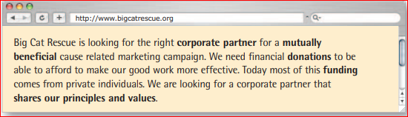
Green marketing is the development and distribution of eco-friendly, or environmentally friendly, goods – for example, washing powder that is not harmful to the environment. 6 degrees.ca is a Canadian web-based forum that promotes green marketing and environmental protection:
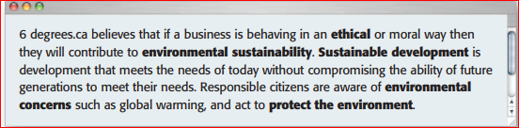
Responsible purchasing is another way that a company can build or maintain a good reputation. Companies can refuse to buy materials or goods made using child labour or that have been tested on animals. As well as showing concern for human rights and animal testing, a company can implement a policy of sustainable purchasing and only buy products that come from renewable sources.
Task01: Make word combinations with market and marketing using words from the box. Then match the word combinations with the definitions below.

