University of Jijel
Department of Trade
Master 1:Tourism & Hotel Marketing Teacher: HADDAD.A

Lesson 5: Customer Needs and Behavior
- Maslow’s Hierarchy of Needs
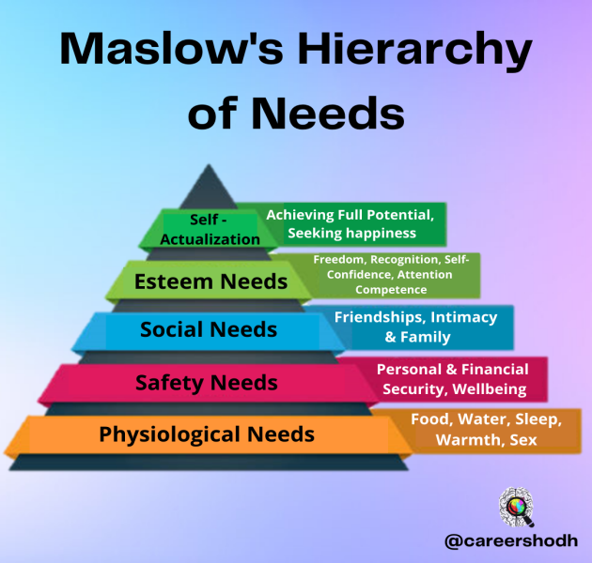
Abraham Maslow was a twentieth-century social psychologist. His pyramid of basic needs is one of the most cited models in marketing.
Matt Robinson, a senior marketer for a high street bank, uses the model in a talk to the management team:
“Imagine that Mr Singh comes to see us about his pension plan. Of course, we talk about his hopes and desires for his retirement. We usually start with how we meet his physiological needs; by this we mean how he will pay for his food and housing – this is a major customer concern. We will also talk about safety needs, how our client will protect himself and his family when he is retired. We think about social needs: will he still be able to afford membership of the golf club? Then there is the Porsche that he drives to the golf club. This is an example of an esteem need – to maintain his lifestyle and social status. There are also self-fulfillment needs; here we consider all Mr Singh’s personal projects and dreams. We have to work out how much money he will need to invest today in order, for example, to be able to travel the world when he retired.”
Marketers are interested in customer needs as these can explain customer wants and desires for a specific product or service.
- What is Consumer Behavior?
Consumer behavior is mental and physical activities undertaken by household and business customers that result in decisions and actions to pay for, purchase and use products and services.
An important part of the marketing process is to understand why a customer or buyer makes a purchase. Without such an understanding, businesses find it hard to respond to the customer’s needs and wants.
For a marketing manager, the challenge is to understand how customers might respond to the different elements of the marketing mix that are presented to them. If management can understand these customer responses better than the competition, then it is a potentially significant source of competitive advantage. Consumer Buying Behavior refers to the buying behavior of the ultimate consumer. A firm needs to analyze buying behavior for:
- Buyers’ reactions to a firms marketing strategy has a great impact on the firm’s success.
- The marketing concept stresses that a firm should create a marketing mix (MM) that satisfies (gives utility to) customers, therefore need to analyze the what, where, when and how consumers buy.
- Consumer Life Cycle (CLC)
Just as products have a life cycle, so do consumers – the Consumer Life Cycle, or CLC.
Matt Robinson talks about this:
“Of course, the banking sector is highly attuned to consumer life cycle – we’re able to understand how a customer’s needs change over time. We exploit this by offering different services as our clients age, from their first savings account as a child, to a first current account, to mortgages, life insurance and retirement plans. Some people criticize us for creating needs, for making people believe they need products that they don’t need. But I really think we try to fulfill or satisfy, customer needs as they change over the years. Younger customers do not have the same desires as retired people.”
- Purchasing Behavior
Purchasing behavior or purchasing patterns refer to what a consumer buys, and when and how they make their final purchasing decision. The first step is usually awareness of the brand. The consumer forms purchase intentions – plans to buy things – which they may or may not act on. Routine purchases of the same products on a repetitive basis (for example, coffee from the coffee machine at the office) have low levels of personal involvement. Major investments (such as buying a car) or impulse purchasing (such as buying some new shoes or a CD on the way home) have higher levels of personal involvement. Some consumers have very high levels of loyalty to a brand or product and they will always buy the same brand.
Task01: Match the needs from Maslow’s pyramid (1-5) with the reasons for buying certain products (a-e).
needs | Reasons for buying
1 Physiological needs  2 Safety needs  3 Social needs  4 Esteem needs  5 Self-fulfillment needs | - A consumer buys a smoke alarm for his house because he wants to be warned if there is a fire.  - A consumer buys the latest fashion accessory so that she can look and feel good  - A consumer buys a chocolate bar because he is hungry.  - A consumer buys popcorn and drinks because he has invited his friends round to watch an important football match on TV.  - A consumer buys a yearly subscription to a swimming pool because she would like to train and win a gold medal at the next Olympic Games.

Activity 2: Correct the mistakes (the underlined words) by using the words from the following list.
Life, need, physiological, lifestyle, to.
- Consumers like to maintain a certain style for life.
- A major customer concern is how to provide his
- self-fulfillment needs.
- Buying food and drink is an example of satisfying a physiological lifestyle.
- Some service sectors are highly attuned with customer needs.
- The Consumer Need Cycle shows how consumer needs change over a period of time.
Task03: Match each expression in column A with its alternative in column B.
Column A | Column B
- The actual decision to buy a product  - Plans to buy  - Shopping habit  - Buying something you like when you see it  - Thought and psychological investment from the consumer  - Purchase without any thought because they are a habit | - Purchase intensions  - Personal involvement  - Final purchasing decision  - Routine purchases  - Purchasing behaviour / purchasing pattern  - Impulse purchasing

