University of Jijel
Department of Trade
Master 1:Tourism & Hotel Marketing Teacher: HADDAD.A

Lesson 04: Product and Service Types
- Product Types:
Raw materials – such as cotton, gold and oil- are used to make, or manufacture, other products.
Product line is a group of related products made and marketed by a manufacturer. There is usually a logical grouping of products- for example, Faber-Castell produce writing instruments, both high quality pencils for children and adults, and also high quality pens.
Product type is a group of products offered by different companies which are technically similar. However, there will be variations in terms of price, appearance and marketing. A good example is cosmetics and
make-up.
Product class is a group of products that may be considered substitutes to one another. H&M and Zara clothes are in the same class. Christian Dior is the same product type but not in the same class.

Word Combination with “goods” and “products”:

convenience
fast moving consumer consumer packaged

white
Products with a high turnover and relatively low price, such as table salt and shampoo.

Major household electrical goods which are usually white, such as freezers, washing machines and dishwashers.

brown perishable durable/ hard nondurable/ soft

goods
Major households electrical goods that are not usually white, such as camcorders, televisions and DVD players.

Goods that have a limited shelf life and must be consumed relatively quickly, such as fresh fruits, fresh meat and eggs.

Goods that last for a long time- they cannot be easily worn out or used up, such as cars, furniture and white goods.

Goods that are used up or last for less than three years- for example perishable goods, consumable supplies such as CD ROMs, or ink for a printer.

Green Products that are not harmful for the environment.

Generic healthcare

Products
Products sold without a brand name, usually in a supermarket or in a pharmacy as alternatives to brand name drugs.

Products that are beneficial for your health and well-being, for example vitamins and plasters.

Types of service
A service is a non-material good, provided by a company or an individual. Common service types are:
Childcare (child minders, kindergartens) Healthcare (doctors, hospitals)
Financial (banking, real estate) Hairdressing (small salons and large groups)
Consulting (business and financial advisors) Telecommunications (mobile phones, fixed lines)
Risk management (insurance and security) Entertainment (cinemas, theaters)
Cleaning and maintenance (office cleaners, Tourism (hotels, airlines)
gardeners) Marketing and advertising (consultancies and
Education and training (private schools, agencies) adults colleges)

Task01: Complete the magazine article by using the following words
Product class, product type, manufacturers(n), raw materials, manufacture(v)

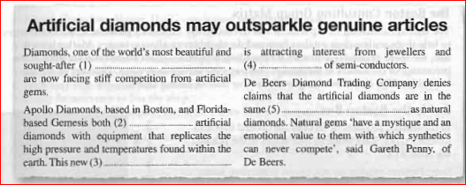

Task02: Make words combination with goods and products using words from the box. One word can be used twice. Than match the word combinations with the pictures (1-7) below.
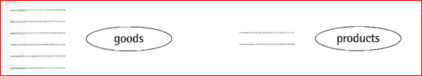
Brown
convenience
hard healthcare
nondurable
perishable
white

