Previewing and Predicting
Introduction
The few minutes you spend preparing before reading any difficult material can motivate you to read it, as well as increase your ability to understand and remember what you read. Preparing to read can also help you estimate how long you’ll take to read so you can plan your time more efficiently. There are Two pre-reading strategies that are essential for a good reader: Previewing and Predicting.

- Previewing

  - Definition

Previewing simply means looking over your reading material in order to become familiar with its content before you actually begin reading it. In this way, you begin thinking about any experiences you may have had with the subject. Previewing is a rapid kind of reading that allows you to get a general sense of what a passage, article, or book is about and how it is organized. Your eyes examine quickly the page looking for answers to general questions about the material.
Previewing is especially useful for getting a general idea of heavy reading like long magazine or newspaper articles, business reports, and non-fiction books. It gives you a quick, overall view of long, unfamiliar material. It can give you as much as half the comprehension in as little as one tenth the time. For example, you should be able to preview eight or ten 100-page reports in an hour. After previewing, you‘ll be able to decide which reports (or which parts of which reports) are worth a closer look. Previewing doesn‘t give you all the details. But it does keep you from spending time on things you don‘t really want -- or need-- to read.

  - Advantages of Previewing

1.Previewing a text can improve comprehension.
2. It helps readers prepare for what they are about to read and set a purpose for reading.
3. It can save time.It helps you read faster by identifying passages that you must read carefully versus those that you can skim or skip.

1.3. Guidelines for Previewing
Here are four steps to follow when previewing a reading passage.
1.Read the Title. The title often will give you the topic or subject of the reading passage. As you read the title, begin thinking about the reading passage. “What is the passage about?” “What kind of information will I learn?” “What do I already know about this subject?”
2.Look at the pictures (if there are any).
3. Read the first few sentences of the First Paragraph. The first paragraph often will give you the main idea of the reading selection. As you read the first paragraph, continue thinking about the material. “Does the first paragraph give me any more specific information about the reading?” What do I know about this subject?” If the selection is very short, such as a single paragraph, you need to read just the first one or two sentences.
4.Read the first line of the other paragraphs.
5.Read the Last Paragraph. The last paragraph often sums up what the author has to say. You get an idea as to what the author feels is most important. Again if the selection is very short, you need to read only the last one or two sentences.
6.Watch for names, dates and numbers. Are there any dates, numbers?
7. Look Over the Passage. Move your eyes quickly over the passage. As you glance over the material, note any key words that might give you additional information about the main idea.Are there any numbers, italicized words, or names in the text?

Example: Read Passage A. It will help you how to preview.
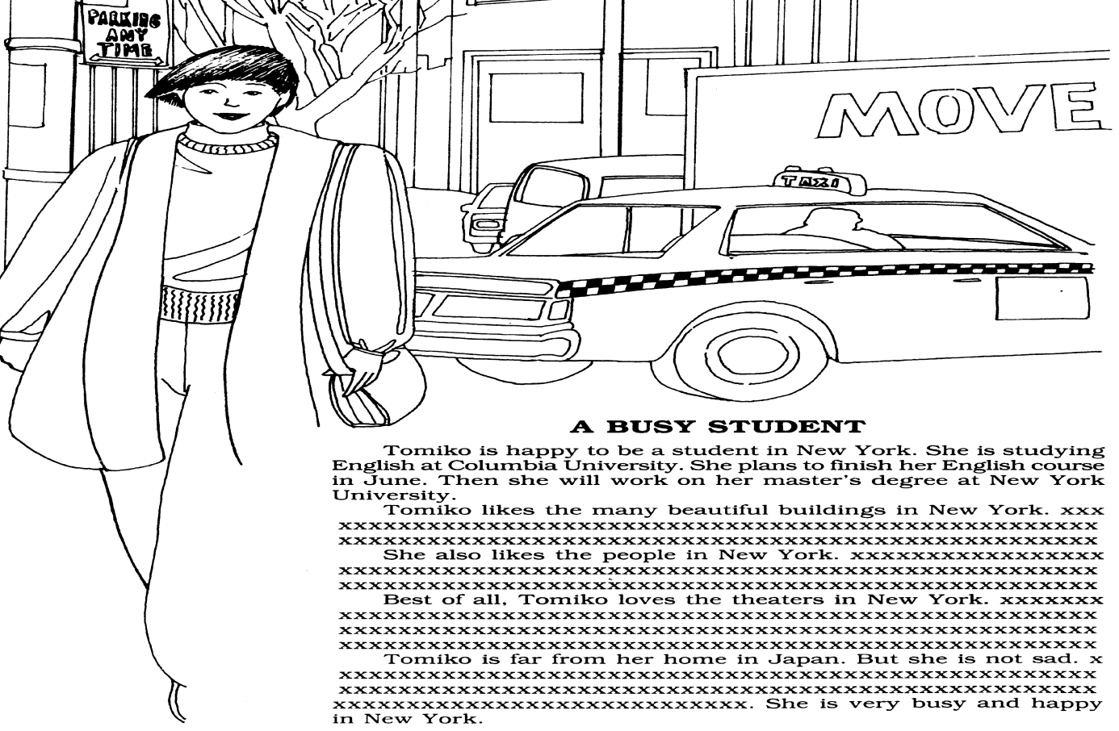
1. This passage is about
a. An American student in New York. b. A Japanese student in New York
c. A Japanese student in Japan d. A Japanese man studying in New York
2. Tomico is
a. unhappy b. happy c. lonely d. not busy
3. She goes to plays in
a. large theatres b. small theatres c. New York d. All of the above
4. Tomiko has
a. few interests b. few friends c. many interests d. nothing to do

Now read the whole passage
How many did you answer correctly? ………………….
Task 1: preview passage B . Read only the underlined sentences. You will have 30 seconds to preview.
Passage B
LANGUAGE LEARNING IN THE UNITED STATES
Circle the best answer . Don’t look back at the passage!
1. Most Americans never learn tp speak
a. English b. a second language c. to people in other countries d. fluently

2. Most Americans speak only English because
a. they cant learn another language b. they never travel to other countries
c. other languages are not important e. they don’t have language classes in school

3. In other parts of the world
a. everyone speaks English b. no one speaks English
c.many people speak English d. everyone speaks a second language

4. Some Americans thinks it is a mistake to
a. learn other languages b. speak only English
c. travel to other countries d. go to school

Now read the whole passage. How many did you answer correctly? ………………….

Task 2: preview passage C . You will have 30 seconds to preview.
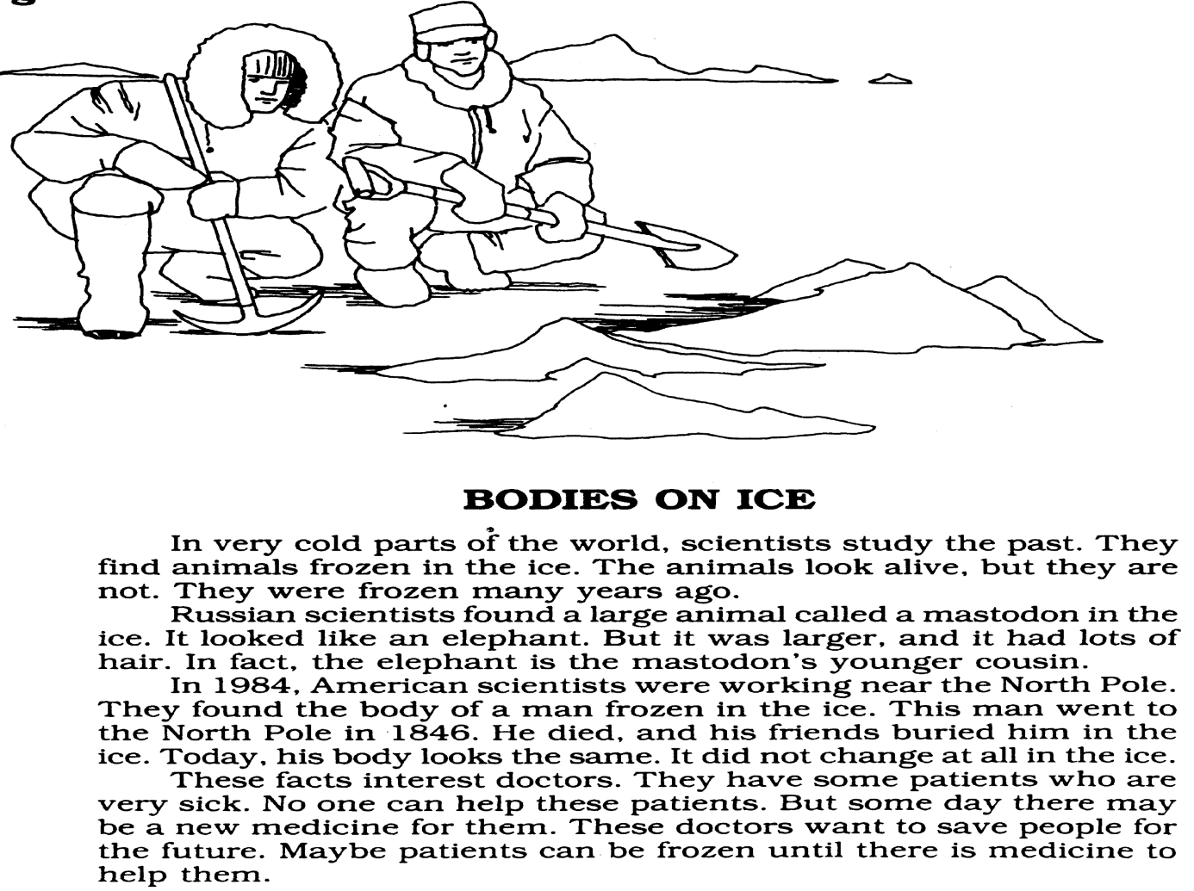
Circle the best answer . Don’t look back at the passage!
1. Scientists are studying the past
a. in the ice b. in the laboratory c. in 1848 d. in Russia

2. Russian scientists found
a. a man in the ice b. a large animal in the ice c. it was too cold d. nothing interesting

3. American scientists worked
a. in Russia b. in the laboratory c. near the North Pole d. with a mastodon

4. Doctors think frozen bodies
a. are too cold b. are near the North Pole c. are interesting d. are mastodons

Now read the whole passage. How many did you answer correctly? ………………….

Task 3: Preview passage D . Read only the underlined sentences. You will have 30 seconds to preview
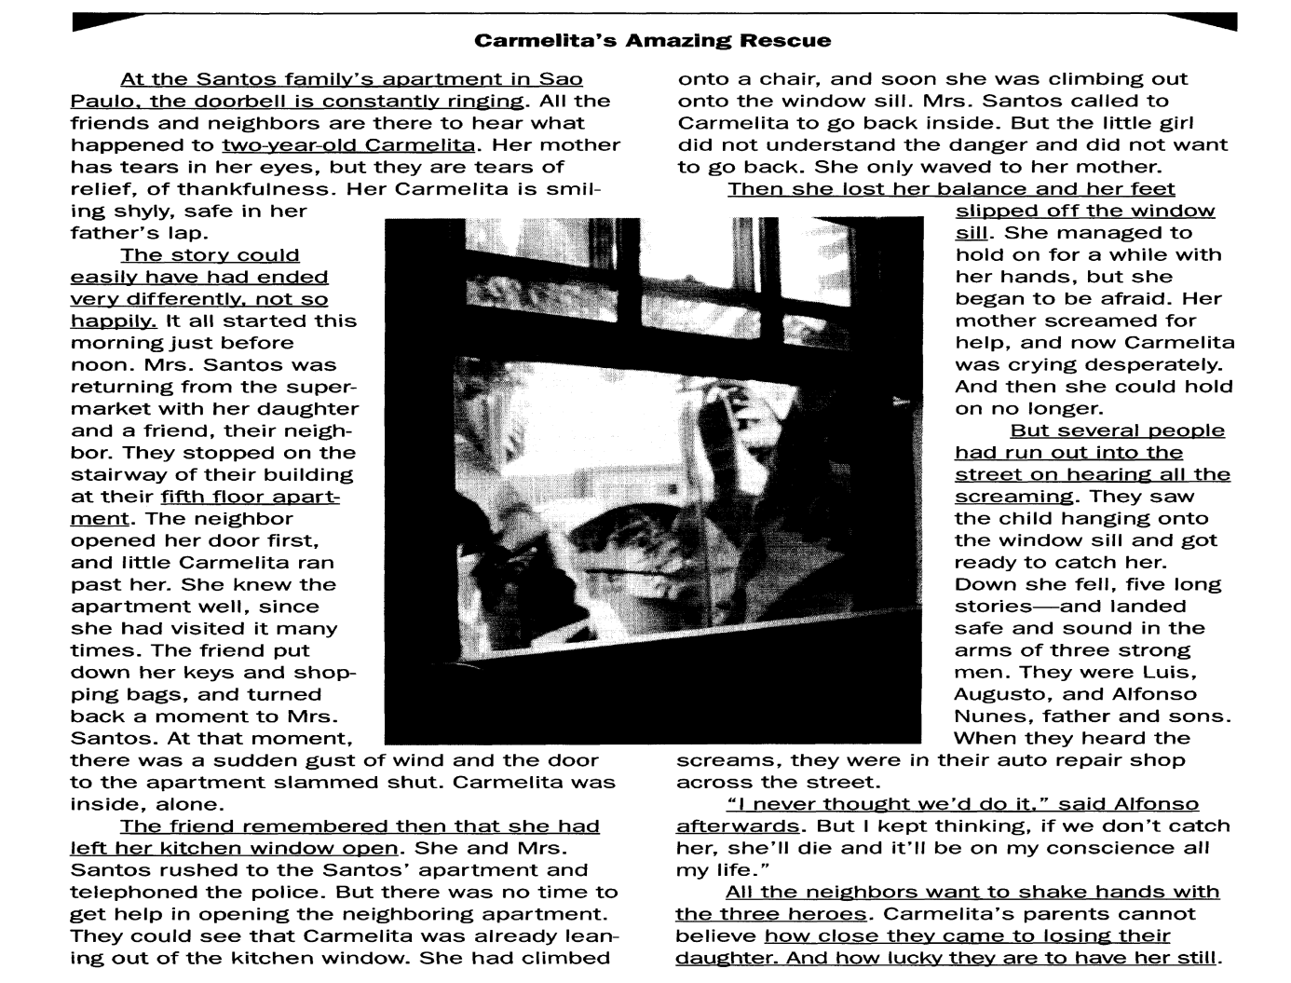
A. Answer the questions. Remember, do not look back!

- Where do you think this passage originally appeared?
…………………………………………………………………………………………………………………………………………..
- Where does this take place?
…………………………………………………………………………………………………………………………………………..
- Who is Carmelita?
……………………………………………………………………………………………………………………………………………
- What happened to her?
…………………………………………………………………………………………………………………………………………..
- What is Alfonso and what did he do?
…………………………………………………………………………………………………………………………………………..
………………………………………………………………………………………………………………………………………….
B. Compare your answers with another student.

Now read the whole passage. How many did you answer correctly? ………………….

