Understanding Paragraphs: the Topic and the Main Idea

1.What is a Paragraph?

A paragraph is a group of sentences that are all about the same thing. That is, they all have the same topic. The purpose of a paragraph is to express a speaker’s thoughts on a particular point in a clear way. In other words, paragraphs shouldnot be mixing thoughts or ideas.
A paragraph is structured around three essential elements: the topic, the main idea and supporting details. As a reader, these elements help you know what to look for and ensure that you will understandand remember what you read.

2. The Topic of a Paragraph

2.1. What is the Topic of a Paragraph?
Every paragraph has a topic to be discussed. A topic is the one thing the whole paragraph is about. It answers the question, “Who or what is the paragraph (or article) about?”. The topic is stated as a single word or phrase—not a complete sentence.

2.2. Finding the Topic
Identifying the topic is important, because it is a key in monitoring our comprehension, getting the full meaning of the text, and answering our instructor when she asks, “So what is this section/passage about?” Once we identify the topic, we can more easily determine the author’s main idea.

Tips for finding the topic:
a. Ask yourself, “Who or what is the paragraph (or article) about? ” .
b. Use these clues to help you:
1. Look for a heading or title.
2. Look for pictures and highlighted words ( such as in bold, italics, …)
3. Read the first and last sentences of the paragraph.
4. Look for repeated words in a paragraph.
5. Look for something mentioned at the beginning of the paragraph and then referred to throughout the
paragraph by pronouns or by other words.
6. Look for ideas that are implied, or suggested, in addition to those stated explicitly.

Examples:Read each paragraph and underline the words that are repeated. Then write a topic that is not too specific or too general.

1) Computer chips have changed our way of life. With computer chips, we can make very small computers.
Space scientists use these small computers in satellites and space ships. Large companies use these small computers for business. We can make very small calculators with computer chips. Some calculators are as small as a credit card, and these calculators are not very expensive. Computer chips are also used for making digital watches. A normal watch has a spring and moving hands, but a digital watch has no moving parts. A digital watch show the time and date with numbers, and some digital watches even have an alarm and a stopwatch. The computer chip makes all of this possible.
Topic : ……………………………………………………………………………

2) In developing countries, poor people have suffered the most from shortages of clean water. There are several reasons for this. First, in many developing countries, the majority of houses in poor villages and urban slums are not yet served by a piped water system. People living in these places often have to walk many miles to find water and carry it home in jugs and plastic containers. Second, these people usually have few alternatives to the piped water supply. There may be water closer by in rivers or lakes, but this is often dangerously polluted. In poor areas, street vendors often sell water by the litre, but they often charge extremely high prices for water that is not always safe to drink.
Topic :…………………………………………………………………………….
Most paragraphs state the topic, but some writers frequently imply the topic. Thus, to identify the topic, readers have to synthesize, or combine, different words in the paragraph. To be useful, the topic you select or create should be general enough to include everything discussed in the paragraph. Read the following paragraph.

Example:
Traffic is directed by colour. Pilot instrument panels, landing strips, road and water crossings are regulated by many coloured light and signs. Factories use colour to distinguish between thoroughfares and work areas. Danger zones are painted in special colours. Lubrication points and removable parts are accentuated by colour. Pipers for transporting water, steam, oil, chemicals, and compressed air, are designated by different colours. Electrical wires and resistances are color-coded.
Topic :…………………………………………………………………………….
3.The Main Idea
In order to become a better and faster reader, recognizing the main idea is a very important skill you should develop.
3.1. What is the Main Idea?
The most important idea in a paragraph is called the main idea. It tells what a paragraph is mostly about. In other words, themain idea is the general sentence that tells about the topic.The main idea is the central point or thought the authorwants to communicate to readers about the topic. Itanswers the question, “What does the author want me toknow about the topic?”.

2. Finding the Main Idea
Before determining the main idea, we should first find the topic. Then ask ourselves these questions: What is the main idea—what is the author trying to say about the topic? Which sentence states the main idea?
It is easy to identify a main idea that is directly expressed in the text. Main ideas are often found at the beginning of paragraphs. The first sentence often explains the subject being discussed in the passage.

Example 1:
Juan loves to play games. His favourite game is chess because it requires a great deal of thought. Juan also likes to play less demanding board games that are based mostly on luck. He prefers Monopoly because it requires luck and skill. If he is done, Juan likes to play action video games as long as they aren't too violent.
In this example, the main idea is found at the beginning of paragraph: ………………………………………..

Example 2:
Does watching violence on TV make people more prone to violence themselves? Obviously, TV violence has some negative effects. One study found that heavy TV watchers are more fearful of others. They try to protect themselves with guns, alarm systems, and security locks on doors. In the same study it was found that heavy TV watchers are less upset about real-life violence than are non-TV watchers. All of the violence they see on TV makes them less sensitive to the real thing. A recent study also found that TV violence increases aggressive behavior in kids and makes them more likely to select toy guns rather than other kinds of toys.
In this example, the main idea is also found at the beginning of paragraph: …………………………………..

Main ideas are also found in the concluding sentences of a paragraph. The main idea can be expressed as a summation of the information in the paragraph.

Example 3:
At the beginning of this century, only eight percent of marriages ended in divorce. In 1976, just over fifty
percent did. The dramatic change doesn’t necessarily mean that people were happy in marriage in the old days and are unhappy today. Expectations have changed, and divorces are now much easier to come by. People who years ago might have suffered along now sever the marriage bond. Yet, however the statistics are interpreted, it is clear that there is a reservoir of dissatisfaction in many marriages.
In this example, the main idea is……………………………………………………………………………….
………………………………………………………………………………………………………………….

Occasionally, a writer does not directly state the main idea of paragraph. Instead, he or she leaves it up to the reader to infer, or reason out, what the main idea of the paragraph is. This type of paragraph contains only details or specifics which relate to a given topic and which substantiate an unstated main idea. To read this type of paragraph, start as you would for paragraphs with stated main idea. Ask yourself the question for finding the topic: What is the one thing the author is discussing throughout the paragraph? Then try to think of a sentence about the topic that all the details included in the paragraph would support.

Example 4:
Thomas Alva Edison invented or improved on the telegraph, phonograph, stock ticker, microphone,telephone, light bulb, battery, motion picture projector, and many other things. He held more than 1,300 US and foreign patents and was the first American director of a research laboratory for inventors. His various companies later combined to become General Electric.

In this example, the topic is ……………………………………..and the main idea is……………………….
………………………………………………………………………………………………………………….

4. Practice:

Task 1:Some of these groups of sentences are paragraphs and some are not. read them carefully and answer the questions.

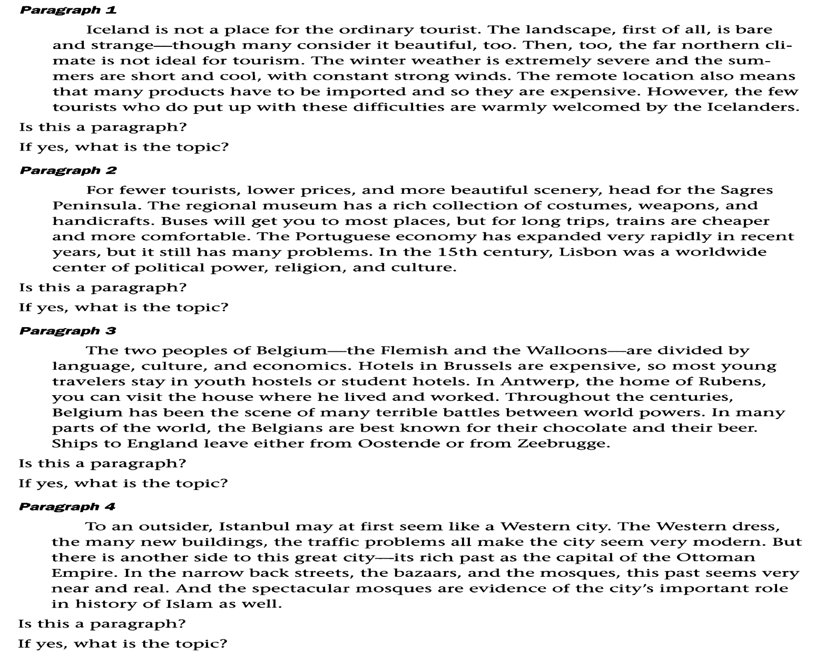
Task 2: Read each paragraph and choose the best topic. Write “too specific” or “too general” after the other topics.

4. Mexico City is growing very fast. In 1970, the city had about nine million people. Now it has over 17 million. All these people are causing problems for the city. There are not enough jobs. Also, there is not enough housing. Large families have to live together in very small homes. Many homes do not have water. They also do not have bathrooms or electricity. The Mexican government is worried about all these problems. It is working hard to make life better in the city.
a. ……………………………………………………………………………………………………………….
b………………………………………………………………………………………………………………..
c…………………………………………………………………………………………………………………

5. Why is Mexico City growing so fast? Where all these people coming from? they are coming to the city from the country. Life is hard on the farms in Mexico. Most people on the farms have to live a very simple life. Thy have no extra money for modern things. People think life in the city must be bettr.so they leave their farms and move to Mexico City.
a. ……………………………………………………………………………………………………………….
b………………………………………………………………………………………………………………..
c…………………………………………………………………………………………………………………

6. All around the world, large cities have the same problem. That problem is air pollution. Mexico City has very bad air. The air there is dirty and very unhealthy. Cars are one reason for the dirty air. Many Mexicans now own their own cars and drive in the city. The factories in the area also cause air pollution. These factories put a lot of smoke into the air. It is not easy to clean up the air in a large city. The government has to make new laws and everyone has to help.
a. ……………………………………………………………………………………………………………….
b………………………………………………………………………………………………………………..
c…………………………………………………………………………………………………………………

7. People have always been interested in bees. This interest may have begun with the honey bees make. In fact, archaeologists have found evidence that people have been eating honey for thousands of years. In the more recent past, people were interested in the way bees made honey. They admired the way bees seemed to work so hard. Some languages even developed expressions about people working like bees. In English, for example, we talk about a “busy bee”. Now scientists have a new reason to be interested in bees. They have discovered that bees are able to communicate with each other. Research has revealed some surprising facts about this, but there are still many mysteries.
a. ……………………………………………………………………………………………………………….
b………………………………………………………………………………………………………………..
c…………………………………………………………………………………………………………………

8. Communication is also possible among bees through their sense of smell. A group of bees , called a colony, uses smell to protect itself from other bees. This is possible because all the bees in a colony have a common smell. This smell acts like a chemical signal. It warns the group of bees when a bee from a different colony is near. This way, bees from outside cannot enter and disturb a hive(thee bee colony’s home). If an outsider does try to enter, the bees of that colony will smell it and attack it.
a. ……………………………………………………………………………………………………………….
b………………………………………………………………………………………………………………..
c…………………………………………………………………………………………………………………

Task 3:After reading each of the following paragraphs, select the choicethat best represents the topic of the paragraph.

9.You’ve probably heard that older men die before older women virtually everywhere in the world. In the United States, women are expected to live an average of 80.4 years, while men live only 75.2 years. Sociologists attribute many factors to this trend. For example, men have higher testosterone levels than women, which may make men more likely to abuse alcohol and tobacco, drive aggressively, and engage in other life-threatening behaviors. Men also choose riskier types of work and become involved in wartime aggression, which are connected to men’s decreased life expectancy. Studies also show that women are less likely to experience life-threatening illnesses and health problems than men are.
a. women’s health b. men and risky behaviors
c. testosterone and aged. men’s life expectancy

10. In the past few years, social networking sites such as MySpace, Facebook, and Twitter have become hugely popular across all ages. Despite the opinions of some that young people are in danger of turning into crouching androids glued to their computers, research shows that the majority of friendships are still maintained offline. Offline friendships are characterized by more interdependence, depth, understanding, and commitment, but online friendships can gain some of these qualities with time. Most online friends tend to be rather cautious about disclosing personal information. However, this does not apply to people with a negative view of themselves and others; they instead seem to share more information, possibly in an attempt to become more self-confident in their interactions. Interestingly, even in online friendships people seem to gain more satisfaction when befriending people of a similar age and place of residence.
a. offline vs. online friendships b. technology and self-image
c. personal information sharing online d. satisfaction in online friendships

11. Compared with the technical resources of a theater of today, those of a London public theater in the time of Queen Elizabeth I seem hopelessly limited. Plays had to be performed by daylight, and scenery had to be kept simple: a table, a chair, a throne, perhaps an artificial tree or two to suggest a forest. But these limitations were, in a sense, advantages. What the theater of today can spell out for us realistically, with massive scenery and electric lighting, Elizabethan playgoers had to imagine and the playwright had to make vivid for them by means of language. Not having a lighting technician to work a panel, Shakespeare had to indicate the dawn by having Horatio, in Hamlet, say in a speech rich in metaphor and descriptive detail: But look, the morn in russet mantle clad Walks o’er the dew of yon high eastward hill.
a. effects of Shakespeare’s writing styleb. impact of technological limitations on Elizabethan theater
c. the use of language to make ideas vivid d. benefits of modern technology in theater performances

Task 4: Read the story and answer the questions.

13. Samuel F. B. Morse is instantly recognized as the inventor of Morse Code—a widely used system of dots and dashes transmitted over wire. His device, the telegraph, eventually made him wealthy and famous. Though Morse is considered a successful inventor, his success was preceded by some very lean years. Morse began not as an inventor but as a painter. Although recognized as talented, he did not make much money at his craft. While on a ship homeward bound from Europe, the almost penniless Morse became fascinated with the idea of sending messages across wires. He took a job as an art teacher and used the little money he made to work on his idea. In 1844, after 12 years of work, he finally succeeded in impressing the world with his invention.
1. What is the main idea of the passage? ………………………………………………………………
2. Was Morse Code named after its inventor? …………………..
3. Did Samuel Morse come from a wealthy background? …………………..
4. Did Morse grow up knowing he wanted to be an inventor? ………………….
5. Was Morse a recognized painter before he invented the telegraph? ………………..
6. Did Morse ever earn much money from his invention? ………………..
7. Did Morse get his idea for the telegraph while on a ship to Europe? ……………….
8. Did Morse spend over a decade working on his invention? ………………..
Task 5: Write the topics for these paragraphs. Be sure they are not too general or too specific. Then write the main ideas.

Topic:……………………………………………………………………………………………………………
Main idea: ……………………….………………………………………………………………………………
Topic:……………………………………………………………………………………………………………
Main idea: ……………………….……………………………………………………………………………… Topic:……………………………………………………………………………………………………………
Main idea: ……………………….………………………………………………………………………………
Topic:……………………………………………………………………………………………………………
Main idea: ……………………….………………………………………………………………………………
Topic:……………………………………………………………………………………………………………
Main idea: ……………………….………………………………………………………………………………

