Understanding Paragraphs: the Topic Sentence and the Supporting Details
1. The Topic Sentence
1.1. What is a Topic Sentence?
A paragraph in English usually contains a topic sentence that lets the reader know what the paragraph is about. It is the most general statement the writer makes about the topic.
What is the most general statement among the following sentences?
1. Animals differ according to when they sleep.
2. Some animals sleep during daylight while others sleep during darkness.
3. Animals’ sleeping habits differ in a number of ways.
4. Hibernation is another kind of sleep for some animals.

What is the topic sentence in the following paragraph?
1Animals’ sleeping habits differ in a number of ways. 2They differ according to what time of day they sleep. 3Some animals sleep during daylight hours while others sleep during darkness. 4They also differ in the length of time they sleep. 5Other animals sleep for weeks or months at a time when they hibernate.

1.2. Tips for Locating Topic Sentences
1. Identify the topic.
2. Locate the most general sentence (the topic sentence). This sentence must be broad enough to include all of the other ideas in the paragraph.
3. Study the rest of the paragraph. The topic sentence must make the rest of the paragraph meaningful. It is the one idea that ties all of the other details together.

1.3. Placement of Topic Sentences
Writers often place their topic sentence first in the paragraph. The topic sentence can also be placed last or in the middle.

Examples:
- Topic Sentence First
There are many ways to feed birds. One way is to put up bird feeders filled with seeds. Blackbirds and cardinals like to eat from feeders. Other birds, such as sparrows, like to eat seeds that are scattered on the ground. Robins enjoy eating pieces of apples and oranges. Planting fruit trees is an even better way to attract birds that have a sweet tooth. If your yard has an oak tree, crows and woodpeckers may pay you a visit. A simple flower garden will attract the beautiful hummingbird.
- Topic Sentence Last
In the developing world 1.1 billion people still lack access to safe drinking water, 2.6 billion do not have access to adequate sanitation services, and more than 1.6 million deaths each year are traced to waterborne diseases (mostly in children under five). All too often in developing countries, water is costly or inaccessible to the poorest in society, while the wealthy have it piped into their homes. In addition, because of the infrastructure that is used to control water, whole seas are being lost, rivers are running dry, millions of people have been displaced to make room for reservoirs, groundwater aquifers are being pumped down, and disputes over water have raised tensions from local to international levels. Fresh water is a limiting resource in many parts of the world and is certain to become even more so as the 21st century unfolds.
- Topic Sentence in Middle
Some United States presidents were once senators or governors. Many were also lawyers. All have been men. But actually there are only a few qualifications for being president. The candidate must be at least 35 years old. The candidate must also have been born in the United States and lived in the country for the last 14 years. Finally, the candidate cannot have served two terms as president already.

2. Supporting Details
The topic sentence states the main, or controlling, idea. The sentences that explain this main point are called supporting details. These details may be facts, reasons, or examples that provide further information about the topic sentence.
Notice how well the topic sentence and details in each paragraph above work together to develop a main idea.
5. Types of Supporting details
Among the most common types of supporting details are illustrations and examples, facts, statistics, reasons, and descriptions, comparisons and contrasts.
a. Illustrations and Examples: Usually, a writer uses examples to make a concept, problem, or process understandable. Example are ways of illustrating your point so that it is better understood.
Example:
All of us live within a culture, one that is qualified by a label like “middle-class American”, ”Roman,” or “Aztec”—a label that conjures up certain objects or behavior patterns typical of this particular culture. For instance, we associate hamburgers with middle-class American culture, and skin canoes with Eskimos. Romans are thought to have spent their time conquering the world. Sioux Indians wandering over the Great Plains. But such stereotypes are often crude, inaccurate generalizations. Though we think of American Indians as legendary, feathered braves, only a few Indian groups ever wore such headdresses. In fact, the label “American Indian” includes an incredibly diverse set of peoples, ranging from family size hunter gatherer bands to large, complex civilizations.
b.Facts: statements from reliable sources about real things.
Example: With fewer cars on the road, there would be less air pollution and traffic noise; therefore, the use of mass transportation should be encouraged.
c.Statistics: facts expressed in numbers, based on data from samples and populations.
Example 1: 75 percent of the students who do not attend class regularly receive grades of C or worse.
Example 2:
Compared with females, males have a great excess of crimes in all nations, all communities within nations, all age groups, all periods of history for which we have statistics, and all types of crime except those related to the female sex, such as abortion. In the United States, males are arrested approximately ten times as frequently as females, and they are committed to prisons and reformatories approximately twenty times as frequently as females. Of the cases coming before juvenile courts, about 85 percent are boys. The official statistics are probably biased in favor of females, but even if correction could be made for the statistical bias, the criminal sex ratio probably would be well over 600 or 700.
d. Reasons: details that tell why an opinion is valid or an event occurs.
Example 1:
There are three reasons why Canada is one of the best countries in the world. First, Canada has an excellent health care system. All Canadians have access to medical services at a reasonable price. Second, Canada has a high standard of education. Students are taught by well-trained teachers and are encouraged to continue studying at university. Finally, Canada’s cities are clean and efficiently managed. Canadian cities have many parks and lots of space for people to live. As a result, Canada is a desirable place to live.
Example 2:
The growth in American higher education is taking place largely in the public colleges and universities. These colleges are usually more responsive than private colleges to state and local demands, and provide training for the increasingly numerous occupation that require advanced skills. They are relatively inexpensive, often easy to enter, and conveniently located to serve large numbers of students. The rapid expansion of college attendance among job-oriented young people of lower social origins is chiefly in these service –minded institutions.
e. Descriptions:Descriptive details are facts that help us visualize the person, object, or event being described.
Example
A newly married pair had boarded this coach at San Antonio. The man’s face was reddened from many days in the wind and sun, and a direct result of his new black clothes was that his brick-colored hands were constantly performing in a most conscious fashion. From time to time he looked down respectfully at his attire. He sat with hand on each knee, like a man waiting in a barber’s shop. The glances he devoted to other passengers were furtive and shy.
f. Comparisons: one thing is shown to be like another.
Example: Like other snails, slugs have slimy skin that allows them to move about and protects their delicate bodies.
g. Contrasts: one thing is shown to differ from another.
Example: Skilled readers are different from unskilled readers in that they use effective strategies.
Practice
Task 1: Read each sentence. Identify it as the topic sentence (TS)or as a supporting sentence (SS)

_____ 1. Kinetic is the energy of motion and action, such as blowing up a balloon.
_____ 2. Energy is described as one of two types—kinetic and potential.
_____ 3. Potential is the energy that is stored with the potential for causing action, such as holding your breath.
_____ 1. Cactus plants are specially adapted to get water in arid environments.
_____ 2. Their roots are very shallow and cover a large area.
_____ 3. This helps the cactus collect as much water as possible from the soil.
_____ 1. Properties include color, size, shape, hardness, and even taste.
_____ 2. Some kinds of properties can be measured, while others cannot.
_____ 3. Property is a way of describing matter.
_____ 1. A prairie dog “town” is made up of many families of prairie dogs.
_____ 2. Each family has one adult male, from one to four females, and several young.
_____ 3. Up to a thousand or more prairie dogs may live in a single “town.”

Task 2:Circle the letters of the two sentences that support the topic sentence.
1. The Andes are a huge chain of mountains.
a. Railroads run through the mountain passes.
b. They run along most of the western edge of South America.
c. This huge mountain chain is about 4,500 miles long.
2. The Andes mountains are rich in mineral deposits.
a. Gold and silver are the most precious minerals mined there.
b. The snow line starts at 4,000 feet.
c. Lead, iron ore, and petroleum can be found there also.
3. Many volcanoes sit within the Andes mountains.
a. Snow covers the top of the volcano.
b. Nevado de Tolima is a dormant, or sleeping, volcano.
c. Cotopaxi in Ecuador is the highest active volcano in the world.
4. Unusual animals live in the Andes of South America.
a. Llamas are well suited for mountain life.
b. Bees are busy insects no matter where in the world they live.
c. The condor is a large Andean bird.
5. These mountains consist of mostly sedimentary rocks.
a. Shale and sandstone are common sedimentary rocks.
b. Sedimentary rocks have visible layers.
c. Fossils provide an interesting glimpse of the past.
Task 3:Read the paragraph and then underline the topic sentence. Next read the sentences below the paragraph. Write D if the sentence tells about detail in the paragraph. Write T if the sentence expresses the same idea as the topic sentence.

Each year, countless numbers of old phone books get recycled into new phone books. Here’s how that happens. People take their old phone books to drop-off locations at stores and supermarkets. The collected books are transported to a warehouse. Here the old phone books are loaded onto trucks and trains to be shipped to a recycling paper mill. The paper mill processes millions of pounds of old phone books into pulp, a mushy mixture like oatmeal. Next, the pulp is made into recycled paper. Huge rolls of yellow and white recycled paper are then shipped to printers, who print phone books for the new year. Finally, new phone books are delivered to homes and businesses. Next year the cycle starts all over again.
____ 1. The paper mill processes the old phone books into pulp.
____ 2. Trucks and trains take the old phone books to the paper mill.
____ 3. People drop off their old phone books to be recycled.
____ 4. Huge numbers of old phone books get recycled each year.
____ 5. Recycled paper is shipped to phone book printers.
____ 6. New phone books are delivered throughout the community.
Task 4: Each of the paragraphs is missing a topic sentence. The missing sentences are listed at the end of the exercise (with one extra sentence). Working with another student, read the paragraphs and write the letter of the sentence that fits each paragraph best.
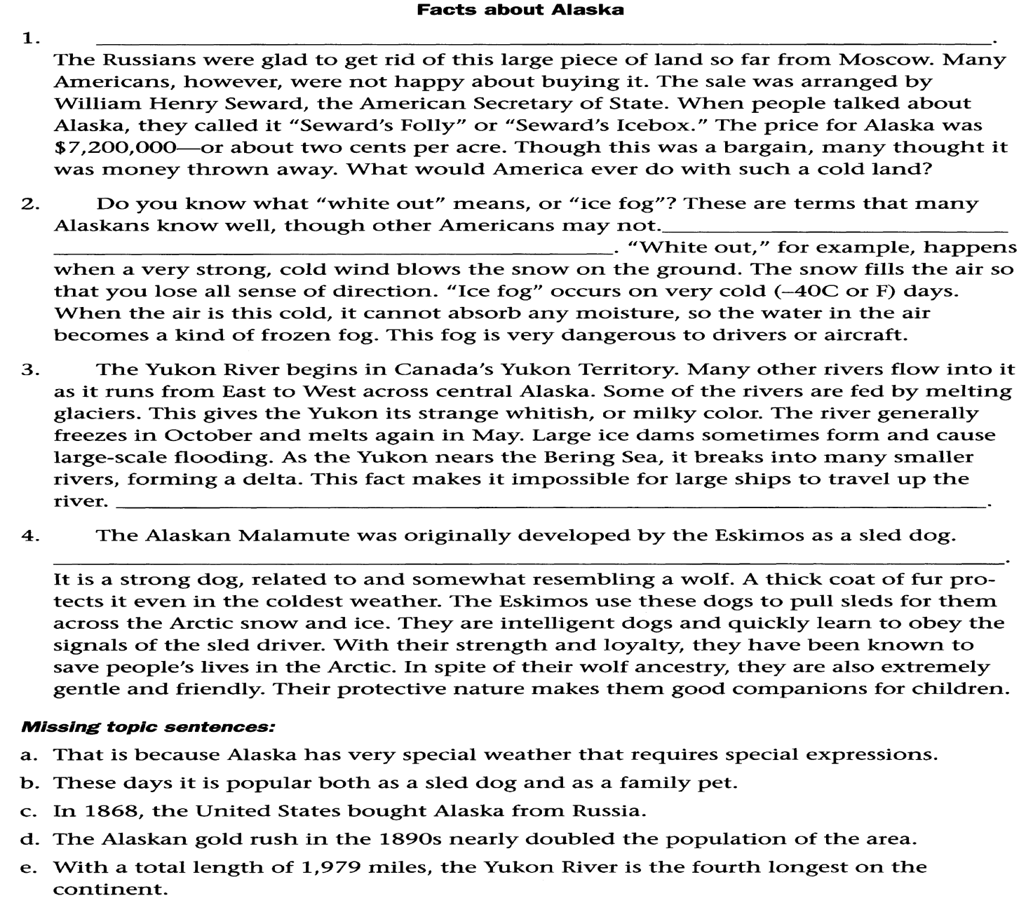
Task 5:Read each paragraph and underline the topic sentence.
4. A focus group is a small group, usually consisting of about seven to ten people who are brought together to discuss a subject of interest to the researcher. Focus groups are commonly used today in business and politics; that flashy slogan you heard for a political campaign or a new toothpaste was almost certainly tested in a focus group to gauge people’s reactions. Social researchers may use a focus group to help design questions or instruments for quantitative research or to study the interactions among group members on a particular subject. In most cases, researchers ask predetermined questions, but the discussion is unstructured. Focus groups are a relatively cheap method of research and can be completed quickly. They also allow for the flexible discussions and answers that are desirable in qualitative research.
5. In colonial days, huge flocks of snowy egrets inhabited the coastal wetlands and marshes of the south-eastern United States. In the 1800s, when fashion dictated fancy hats adorned with feathers, egrets and other birds were hunted for their plumage. By the late 1800s, egrets were almost extinct. In 1886, the newly formed National Audubon Society began a press campaign to shame “feather wearers” and end the practice. The campaign caught on, and gradually, attitudes changed; new laws followed. Government policies that protect animals from overharvesting are essential to keep species from the brink of extinction. Even when cultural standards change due to the efforts of individual groups (such as the National Audubon Society), laws and policy measures must follow to ensure that endangered populations remain protected. Since the 1800s, several important laws have been passed to protect a wide variety of species.

Task 6: Read the passage and answer the questions below.

You may think there were no lamps before Edison invented the electric light about years ago. But there have been forms of lamps since prehistoric times. The first lamps may have been brush set afire in an animal skull filled with fat. Later, but still thousands of years ago, Egyptians placed cotton wicks inside hollow stones filled with grease. Greeks and Romans shaped lamps from bronze or terra cotta and used olive oil for fuel. Candles were a great improvement when they appeared. In the 1700s the discovery that under glass a flame burns more brightly and with less smoke led to glass encasements. Whale oil was the main source of fuel at this time until scientists learned to use gas as a fuel. In the 1800s, kerosene lamps appeared on the scene. Prior to Edison’s invention, gaslight lamps were widely used. They were not only functional but also sometimes ornate decorations for the home.
1 Write the topic sentence.
…………………………………………………………………………………………………..
2. List three supporting details.
……………………………………………………………………………………………………………………………………………………………………………………………………………………………………………………………………………………………………….
2. What was used as fuel in the first lamps?
a. gas b. animal fat c. olive oil
3. During what period did candles appear as a source of light?
a. prehistoric b. 1800s c. passage doesn’t say
4. During the 1700s, what was the main source of fuel in lamps?
a. whale oil b. olive oil c. grease
5. About what year did Edison invent the electric light?
a. 1775 b.1823 c. 1879
6. Who invented the gaslight lamp?
a. Greeks and Romans b. Edison c. passage doesn’t say
Task 7:Read each of the following passages to identify the topic, the main idea, the topic sentence and the supporting details.

1) Everyone needs a good night’s sleep. Sleep gives the body a chance to heal and refresh itself. A proper amount of sleep can give you a better mental attitude and also help your mind be more alert. Sleep restores your energy source and allows you to perform better in physical activities. Doctors recommend that children get 9–12 hours of sleep every night.

2) Water is one of the most important elements in nature. All plants and animals need water to survive. Much of the human body is made of water. Water comes from nature. We get our water from rivers, streams, and rain. It is important that our water sources are kept unpolluted. Without clean water, no plant or creature will be able to survive for very long.
3) Success in college depends on many things, but one of the most important is having a positive attitude. There are many ways to develop a positive outlook. You can try using encouraging self-talk to motivate yourself. For example, if you tell yourself that you are smart and can be successful, you are more likely to do well in your classes. Helping others to be successful is also a way of maintaining a positive attitude. When you see that college is not a competition, you will see success come to you and those who work closely with you. Finally, you can develop a positive attitude by viewing difficult situations as opportunities to grow. For example, if you are struggling in a class because the material is challenging, don't let yourself feel down about it. Instead, take action! Visit with your professor or form a study group. Getting help will enable you to learn the material and therefore do better in your class. By using encouraging self-talk, helping others, and utilizing difficult moments as an opportunity to grow, you will have the optimistic outlook that will enable you to succeed in college—and in life!

4) John F. Kennedy was the 35th president of the United States of America. At only 43 years old, he was the youngest man ever to be elected President. In 1963, when he was killed, he was also the youngest man to die as president. Many people saw the time of Kennedy’s service in office as a time of great optimism and good fortune in the United States. Thus, when he died, many people not only saw it as a tragedy, but as an end to
a vigorous period.

5) Origami is the art of paper folding. It was developed in Asia. You can make many different shapes, including animals and birds, with one piece of paper. Origami is not hard, but it does take some practice. You have to learn how to fold the paper correctly the first time so that your art will look good when it is done. Origami is closely related to the mathematical science of geometry.

6) Polar bears look white but they don’t have white fur. It is actually colorless. Underneath the fur the polar bear has black skin. Their fur is actually hollow hair shafts and the reflection of light make it appear white. The Polar bear’s thick coat protects it from the cold and camouflages it on the ice.

7) There are two primary reasons why elephants are endangered. First, their homes are being destroyed. When man moves into new lands, where elephants lived before, he destroys their natural habitat, or the place where they live. With fewer and fewer places to live, the number of elephants has dropped. Secondly, they have been hunted almost to extinction. At one time it was legal to hunt elephants. Now it is not. Still, people poach, or illegally hunt, elephants for their ivory tusks.

8) Inoculation is a way of protecting people from infection. Sometimes inoculation is called vaccination. When you get an inoculation, you are given a very small dose of the disease. Your immune system produces cells which help you to fight off the disease. Once you have produced these cells, you have little chance of ever being infected with the disease.

9) There are basically two types of computers—analog computers and digital computers. Analog computers operate on the principle of a parallel or analog between numbers and physical quantities. For example, a slide rule is an analog device with length representing numbers. Modern analog computers use electronic circuitry to represent physical process with changes in electric current representing the behavior of the system being studied. Digital computers, on the other hand, are essentially based on counting operations. Most modern computers are digital computers, and it is usually digital computers which are referred to when the word “computer” is used.

10) Consumers concerned about the hazards or noise can reduce noise pollution in many ways. They can purchase noisy products such as garbage disposals and lawn mowers with reduced noise levels. They can also use sound-absorbing materials in their home. Carpeting can be installed instead of hard flooring, and cork and fabric can be used in rooms that tend to be noisy. Also, people can become less noisy themselves. They can learn to avoid shouting, to close doors without slamming them, and to play radios, TV sets, and stereos at moderate levels.

