CHAPTER I: THE MAIN THEOREMS OF EUCLIDEAN GEOMETRY

Introduction to Euclidean Geometry

Definition and Origins
Euclidean geometry, also known as plane geometry or plane Euclidean geometry, is a fundamental branch of mathematics that finds its origins in the magisterial work of Euclid, a Greek mathematician who lived in the 3rd century BC.His exceptional contribution to geometry laid the foundation for a discipline that would profoundly influence mathematical thinking and architecture through the ages. Euclidean geometry is a branch of geometry that focuses on the study of geometric objects in a two-dimensional plane, that is, objects such as points, lines, segments, polygons, and circles, as well as their properties and relationships.It is based on a set of axioms, or basic statements, that serve as foundations for all geometrical deductions. These axioms, as well as other elementary propositions, are at the heart of Euclidean geometry and were carefully presented by Euclid in his work "Elements" (in Greek: "Στοιχεῖα" or "Stoikheîa"). This book, consisting of 13 independent books, is one of the most influential works in the history of mathematics.
Euclidean geometry is named after Euclid, a Greek mathematician who lived around 300 BC. Euclid was a scholar active at the Library of Alexandria, one of the most important intellectual centres of antiquity. His work "Elements" is a systematic collection of geometrical knowledge, but he also covered topics such as arithmetic and number theory. Euclid's influence on mathematics and mathematics education has been immense. His writings have been widely studied and translated into many languages, and "Elements" has become the standard textbook for teaching geometry for centuries.

The Five Postulates of Euclidean Geometry
The five postulates of Euclidean geometry, also known as Euclid's axioms, are fundamental statements that serve as the basis for Euclidean geometry. These postulates define the fundamental rules governing geometric objects in a two-dimensional plane.
- Postulate 1: Two points determine a straight line.
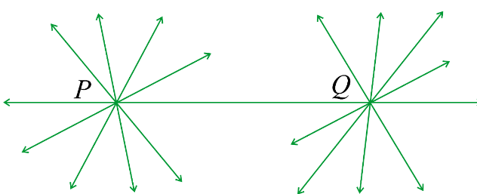
This first postulate states that if you have two distinct points (that is, two points that do not overlap) in a plane, then there is a unique straight line that passes through these two points. In other words, it is possible to connect any pair of points by a straight line and this straight line is unique.
- Postulate 2: A line segment can be extended indefinitely.
This postulate means that if you have a line segment, you can extend this segment in both directions indefinitely without ever reaching an end. In other words, a line is infinitely long in both directions.
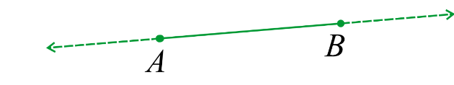
- Postulate 3: A circle can be described from any point as a center and a fixed distance as a radius.
This postulate explains how to construct a circle. It states that to create a circle, you can choose any point as the center, and then fix a fixed distance from that point to determine the radius of the circle. By drawing a circle from that center with that radius, you get a unique circle.
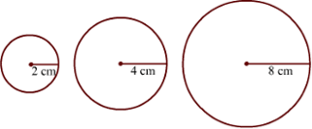
- Postulate 4: All right angles are equal to each other.
This means that all right angles, that is, angles measuring 90 degrees, are equivalent. No matter where they are located in the plane, all right angles are the same size. This ensures the consistency and constancy of angular measurements in Euclidean geometry.
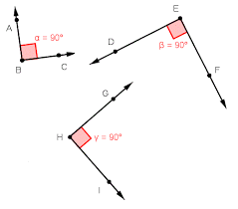
- Postulate 5: Through a point outside a line, there passes one and only one parallel to that line.
This postulate states an important rule for constructing parallel lines. It says that if you have a line and a point that is not on that line, you can always draw one and only one straight line that passes through that point and that is parallel to the first line. This means that there is only one possible parallel in this situation.
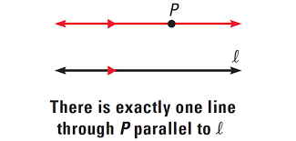
These five postulates form the basis of Euclidean geometry. They have been accepted as self-evident truths for centuries and have served as a solid foundation for the development of classical geometry. However, in the 19th century, mathematicians began to explore other geometric systems, such as non-Euclidean geometry, where some of these postulates are modified or abandoned, thus challenging the notion of a unique and universal geometry.

Importance of Euclidean Geometry in Architecture
Euclidean geometry, often called plane geometry, has played a central role in the field of architecture for thousands of years. As an architect, understanding the basic principles of Euclidean geometry is essential for the design, planning, and construction of buildings. In this section, we will explore in depth the importance of Euclidean geometry in architecture.

1.3.1 Foundations of Architectural Design
Euclidean geometry provides a solid set of mathematical rules that underlie architectural design. Architects use straight lines, angles, circles, and other geometric shapes to create plans, elevations, and models of buildings. Understanding geometric properties allows for the design of stable, balanced, and aesthetically pleasing structures.

Accuracy of Measurements
In architecture, the accuracy of measurements is essential. Architects use Euclidean geometry to determine the exact dimensions of a building, from walls to openings to stairs and roofs. Geometric calculations ensure that each element fits together harmoniously and functions properly.

Drawing Plans and Elevations
When designing a building, plans and elevations are crucial tools. Euclidean geometry is used to draw floor plans, cross-sections, and elevations of each part of a building. These drawings are essential for communicating ideas to clients, engineers, and contractors.

Space Management
Euclidean geometry helps architects maximize the use of space. Concepts such as room layouts, ceiling heights, window placement, and the creation of open or closed plans are all based on geometric principles. This allows for the creation of functional and aesthetic spaces.

Architectural Elements
Euclidean geometry is also fundamental to the design of architectural elements such as arches, columns, vaults, and domes. These elements are designed using complex geometric shapes and precise calculations to ensure their stability and beauty.

Modernity and Tradition
Even in the age of computer-aided design (CAD), Euclidean geometry remains relevant. CAD software uses geometric principles to create 3D models, simulate structures, and generate detailed plans. This modern technology relies on the geometric foundations established by Euclid.

Theorem of Pythagore

Statement of the Theorem
In a right triangle, the square of the length of the hypotenuse (the side opposite the right angle) is equal to the sum of the squares of the lengths of the other two sides. Mathematically, if we denote the lengths of the sides of a right triangle as follows:
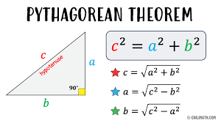
- The length of the hypotenuse: c
- The length of one of the sides adjacent to the right angle: a
- The length of the other side adjacent to the right angle: b
The Pythagorean theorem can be expressed by the following equation:
c² = a² + b²
In other words, the sum of the squares of the lengths of the sides adjacent to the right angle is equal to the square of the length of the hypotenuse. This theorem is fundamental in geometry and is used to solve many problems related to right triangles, especially in trigonometry and analytical geometry.

Proof and Applications
Let's consider a right triangle ABC where the angle at 90 degrees is at angle B. The sides of the triangle are as follows:
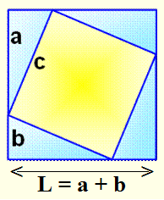
- The hypotenuse (the side opposite the right angle): c
- The side adjacent to angle $β$: a
- The side opposite angle $β$: b

The Pythagorean theorem has many practical applications in various fields, including:
  - Architecture: Architects use it to ensure that angles are right, and buildings are constructed stably.
  - Geodesy: Surveyors use it to measure distances on large surfaces, including the Earth.
  - Navigation: Navigators use it to calculate distances and courses at sea.
  - Engineering: Engineers use it in the design of structures, electrical circuits, and even in solving complex problems in mechanics and acoustics.
  - Trigonometry: The Pythagorean theorem is fundamental in trigonometry and is used to derive trigonometric functions such as sine, cosine, and tangent.
  - Computer Science: It is used in algorithms for distance calculations, GPS positioning, and image analysis.

Theorem of Thales
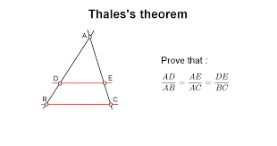

Statement of the theorem
If A, B, and D, are three points on a straight line
(i.e., collinear) and C is a point on another line
parallel to the first line, then the segments
formed by these points are proportional. In other words,
the lengths of the segments AD, AB, and AC are related by the same proportion, regardless of the position of point C.
Mathematically, this can be expressed as follows: If points A, B, D, and C are such that A, B, and D, are collinear, and if $\frac{AD}{AB} = \frac{AE}{AC} =\frac{DE}{BC}$, then the Theorem of Thales establishes that these segments are proportional.
This theorem is fundamental in geometry and is often used to solve problems involving proportions and similar triangles. It is named after the Greek mathematician Thales of Miletus, who lived in the 6th century BC and is one of the first to have formulated this geometrical principle.

Demonstration and Applications
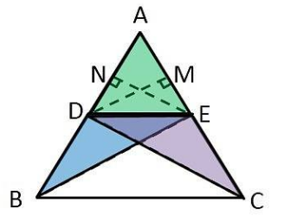
Consider ABC as a triangle, and let DE be a
line parallel to the line passing through B and C,
where D belongs to line AB, and E belongs to line AC.
We need to demonstrate that the segments AD/DB = AE/EC.

Thales' theorem has numerous applications in various fields, including:
• Geometry: It is used to solve proportion problems in triangles and similar geometric figures.
• Trigonometry: It is used to derive trigonometric laws within triangles.
• Cartography: It is used to calculate distances and proportions on maps and aerial photographs.
• Engineering: It is used for designing and sizing structures, electrical circuits, and communication networks.
• Optics: It is used to solve problems related to the refraction of light.
• Economics: It is used in calculations involving exchange rates, percentages, and financial situations.
• Education: It is taught as a fundamental concept in mathematics and geometry, helping students understand proportions.
Thales' theorem is a powerful tool for solving a wide variety of problems involving proportions and similar geometric figures. It is widely used in many fields to perform calculations and make decisions based on proportion relationships.

Projective geometry

Introduction to projective geometry
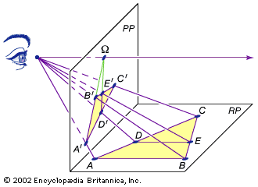
Projective geometry is the study of the properties of geometric
figures that are invariant under projection. A projection is
a transformation that maps a point or figure from one
space to another while preserving the projective relations.
Unlike Euclidean geometry, which focuses on the metric
properties of objects (length, angle, etc.), projective geometry
focuses on properties that do not change under projection, regardless of distance or angle.
A key concept in projective geometry is the "point at infinity," which is introduced to extend the geometry to infinity and allow the manipulation of objects at infinite distance. This idea is particularly useful in architecture for understanding perspective, vanishing points, and the visual representation of buildings and spaces.

Relation to Euclidean geometry
Projective geometry can be considered an extension of Euclidean geometry. While Euclidean geometry is based on metric concepts, projective geometry focuses on projective concepts, which means that it can capture properties that do not depend on size or distance. This makes it a powerful tool for architects, as it allows them to represent spaces realistically and explore the viewpoints of viewers.
In architecture, projective geometry is commonly used for the design of buildings, the creation of perspectives, and three-dimensional modeling. It helps to understand how architectural elements appear visually in different contexts and at different scales. Architects also use concepts such as vanishing lines to create compelling architectural renderings.

Applications in architecture
Euclidean geometry is at the heart of architectural design. It allows architects to create functional, aesthetic, and sustainable buildings by using fundamental mathematical principles. Theorems and geometric concepts are essential tools for turning architectural ideas into built reality.

Use of theorems in architectural design
Euclidean geometry, with its fundamental principles and theorems, plays an essential role in architectural design. This section explores how architects use Euclidean geometry to design buildings, plan spaces, and create harmonious structures.

Geometric foundations in architecture:
Even before laying the first stone, architects must establish solid foundations based on Euclidean geometry. Key concepts include right angles, straight lines, polygons, and circles. Architects use these concepts to create accurate plans, elevations, and models of their projects.

Pythagorean Theorem in Architectural Design:
The Pythagorean Theorem is widely used in architecture to ensure that structures are stable and angles are right. It allows for the calculation of the lengths of the sides of a right triangle, which is essential for the layout of foundations, walls, and structural elements.

Construction of rectilinear buildings:
Euclidean geometry is crucial for designing rectilinear buildings with right angles. Architects use straight lines to align walls, windows, and doors, thus ensuring the functional and aesthetic appearance of indoor and outdoor spaces.

Polygons in architecture:
The classification of polygons and the properties of triangles and quadrilaterals are used to create complex architectural plans. For example, architects can divide a space into triangles to optimize structural stability or create unique polyhedral shapes for iconic buildings.

Circles and architectural arches:
Circles and arches are frequently used in architecture to create architectural elements such as domes, vaults, and flying buttresses. Euclidean geometry allows for the precise calculation of radii, arcs of circles, and curves, thus contributing to the beauty and stability of buildings.

3D modeling and CAD:
Computer-aided design (CAD) software relies on concepts of Euclidean geometry to create 3D models of buildings. Architects use these tools to visualize and optimize their designs, thus ensuring maximum precision in architectural planning.

Sustainability and material economy:
By using geometric principles, architects can design structures that maximize material efficiency while minimizing waste. This contributes to the environmental sustainability of buildings.

Case studies of architecture using Euclidean geometry (the Great Pyramid of Giza)
The Great Pyramid of Giza is one of the most iconic monuments of ancient Egypt and an exceptional example of the application of Euclidean geometry in architecture. This pyramid, built about 4,500 years ago, relies on advanced mathematical and geometrical principles to achieve exceptional structural stability.

Square base:
The Great Pyramid of Giza has a perfectly aligned square base with the cardinal points. Euclidean geometry was used to ensure that the sides of the base were the same length and that the angles were right angles.

Pythagorean theorem:
Egyptian architects used the Pythagorean theorem to ensure that the sides of the pyramid were in harmonious proportion. The triangles formed by the sides of the pyramid were right triangles, which helped to ensure structural stability.

Accuracy in measurements:
The ancient Egyptians used precise measuring instruments, such as the 13-knot rope, to ensure the accuracy of geometric measurements. This allowed for the construction of a pyramid with extremely precise proportions.

Symmetry and alignment:
Euclidean geometry was used to ensure the perfect symmetry and alignment of the pyramid. The sides of the pyramid were perfectly perpendicular to each other, and the sides were aligned with the cardinal points, which had important astronomical significance.

Height and slope:
The height of the pyramid, as well as the angle of slope of the sides, were calculated with great precision to create a pyramid that was not only aesthetically harmonious, but also stable.

Conclusion:
The Great Pyramid of Giza is a masterpiece of engineering and architecture that demonstrates the advanced use of Euclidean geometry by the ancient Egyptians. Its geometric precision, astronomical alignment, and structural stability make it a remarkable example of the application of mathematical principles in architecture. It is also a testament to the importance of Euclidean geometry in the creation of durable and iconic architectural structures that withstand the test of time.

