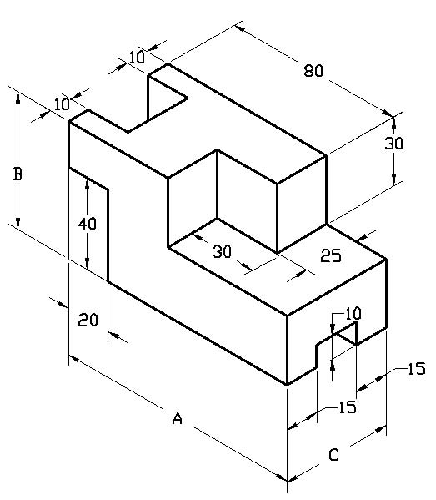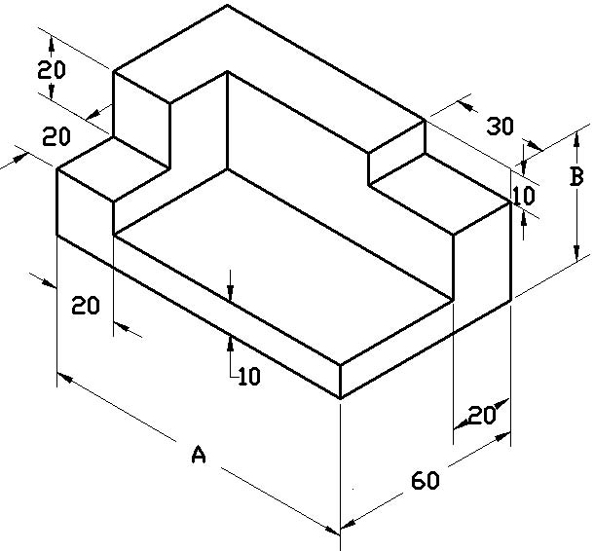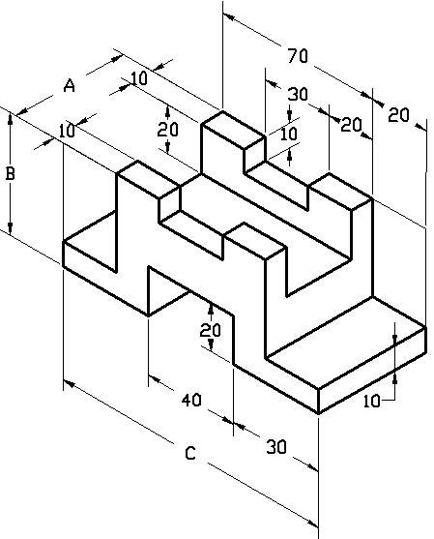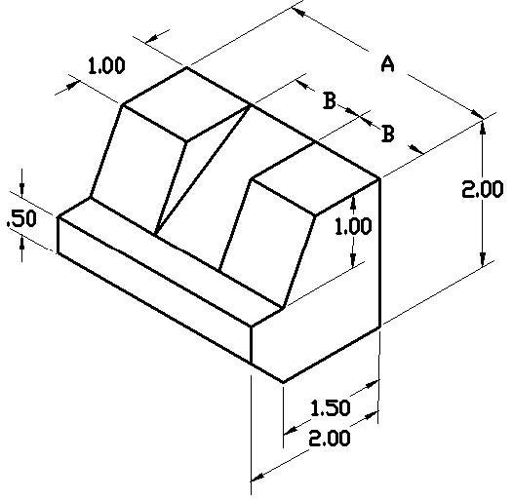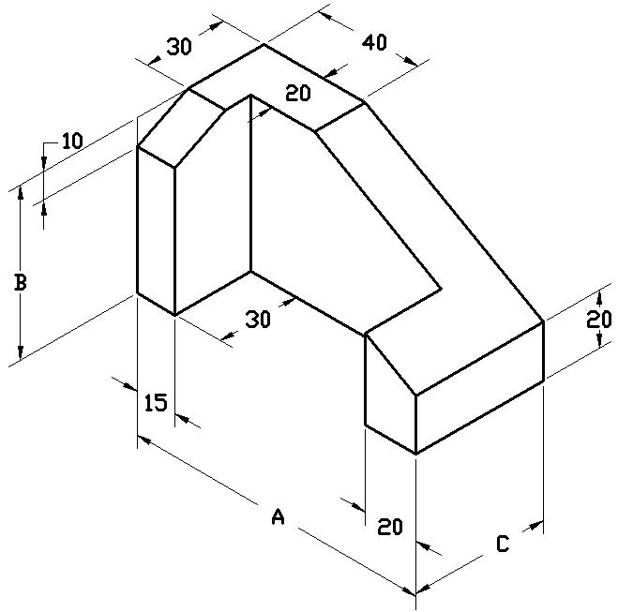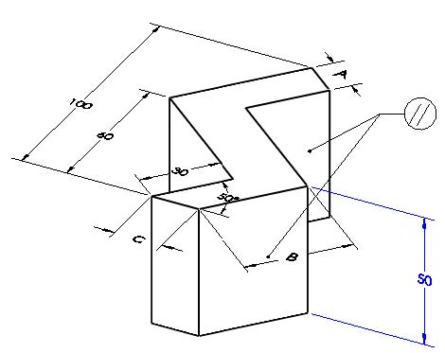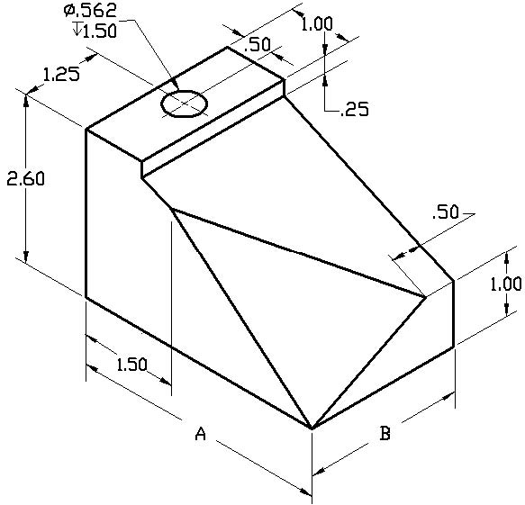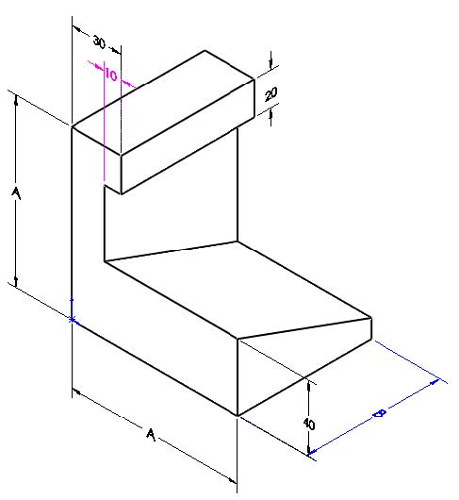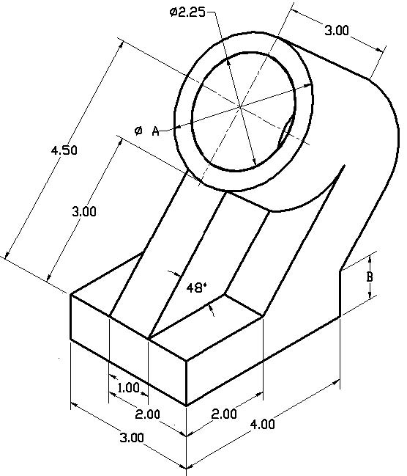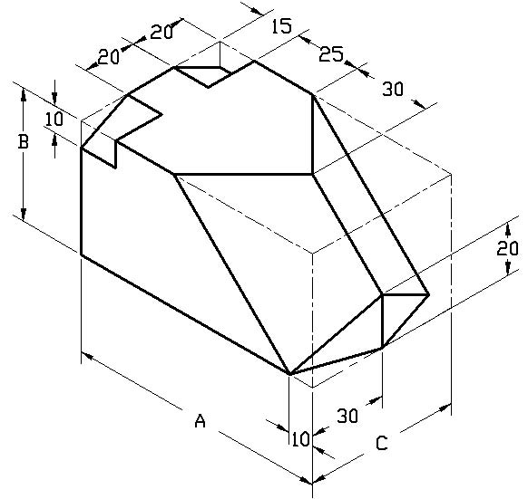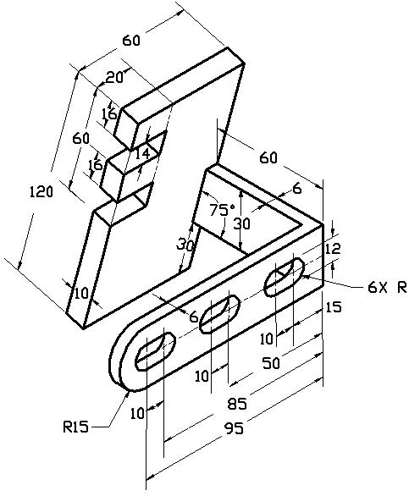
A = 110, B = 60, C = 50
6
5
3
4
A = 110, B = 40
A = 50, B = 50 ,C=120
A = 110, B = 60, C = 50
A = 3.00, B = 1.00
A = 110, B = 60, C = 50
A = 110, B = 60, C = 50
2
1
A = 4.00, B = 2.50
A = 16
B = 40
C = 16
10
8
7
A = 3.00
B = 1.00
A = 100
B = 60
9
A = 100
B = 50
C = 60
12
11

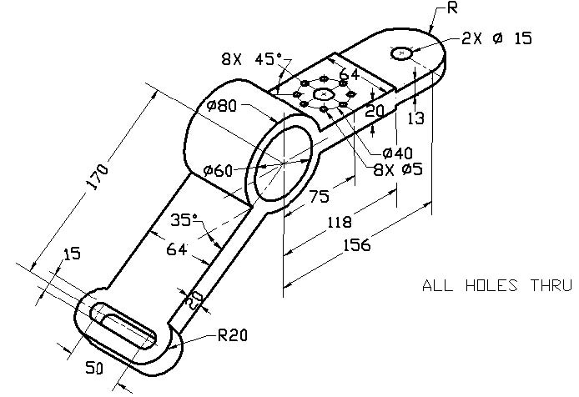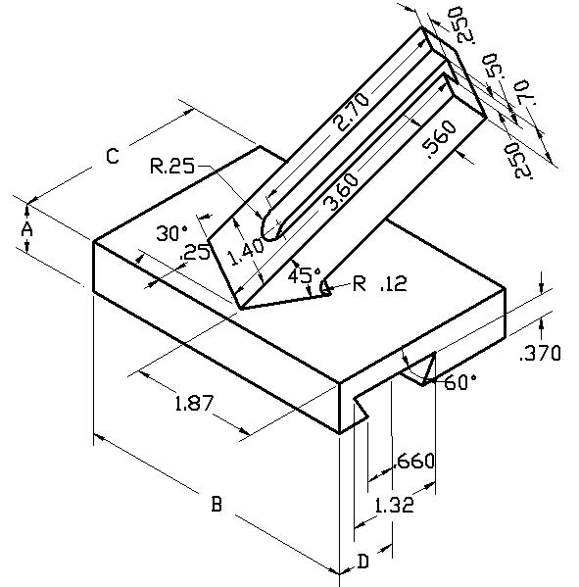
A = 0.700, B = 4.000, C =2.700
D=0.900

16
14
13
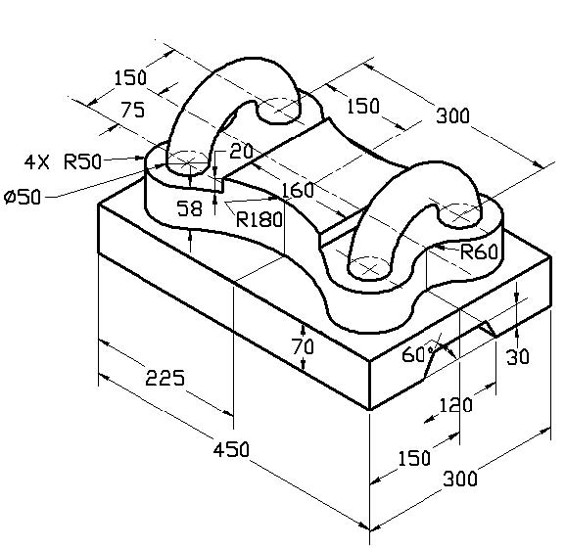
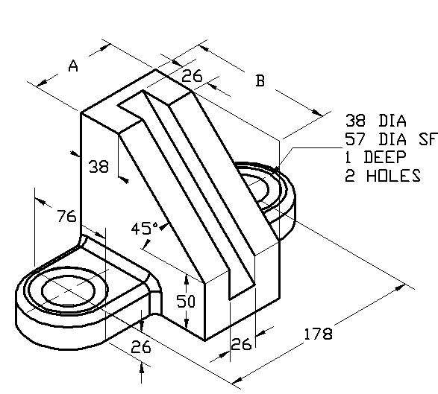
A =76
B = 127

15

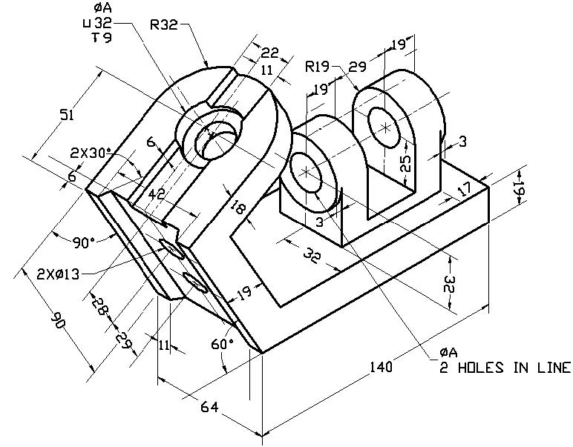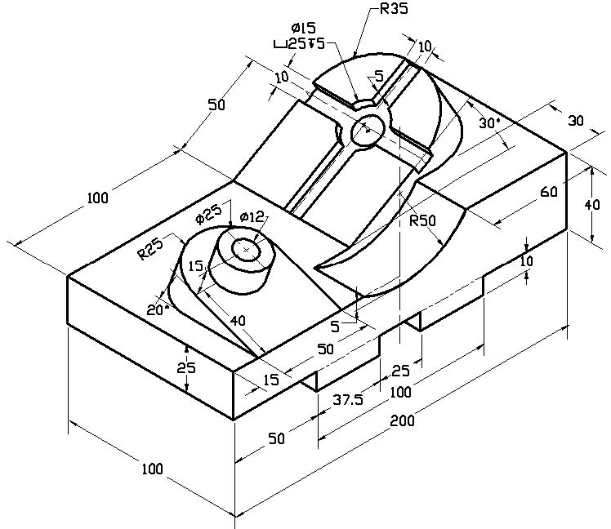
17
18
A = Ø 19

A = 70
B = 76
20
19
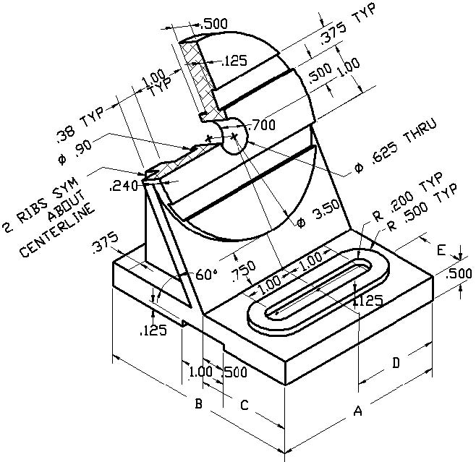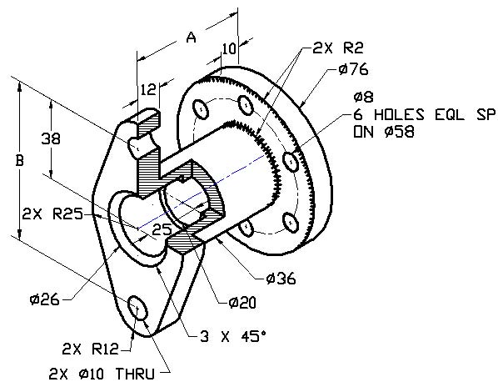
A = 3.500, B = 4.200
C = 2.000, D=1.750, E=1.000
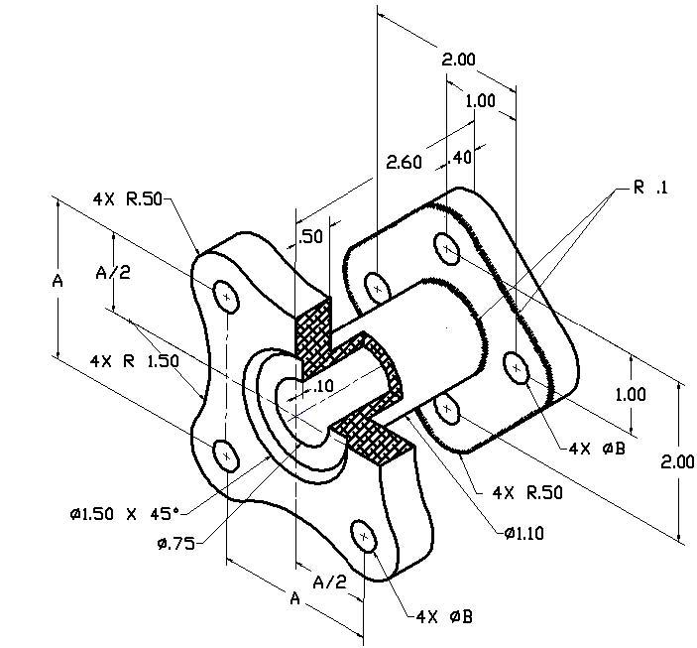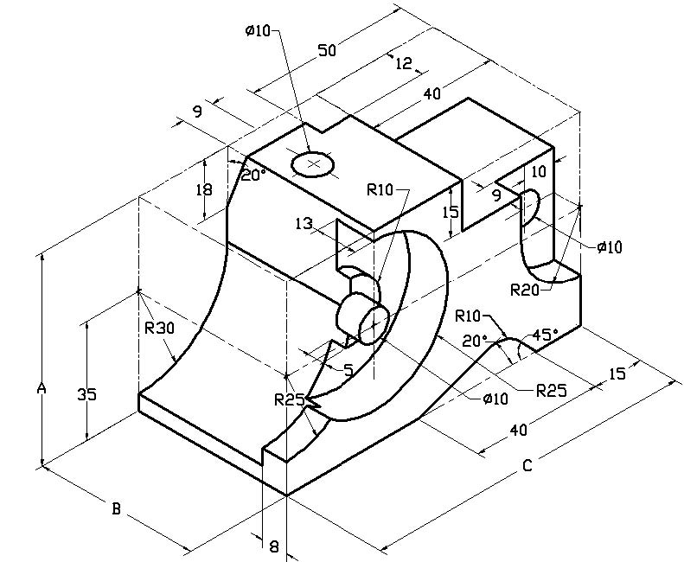
A = 110
B = 65
C = 5 X 45Ø CHAMFREIN
A = 2.00
B = Ø0.35

A = 63
B = 50
C = 100
24
23
22
21
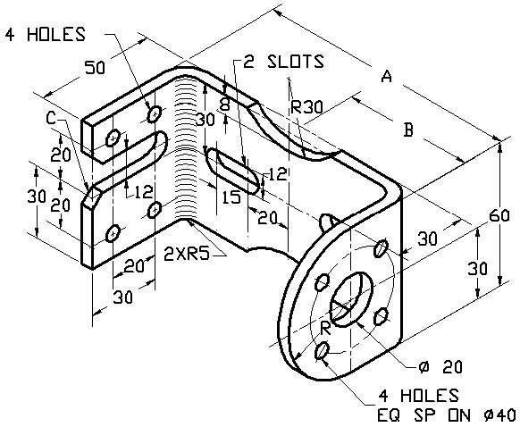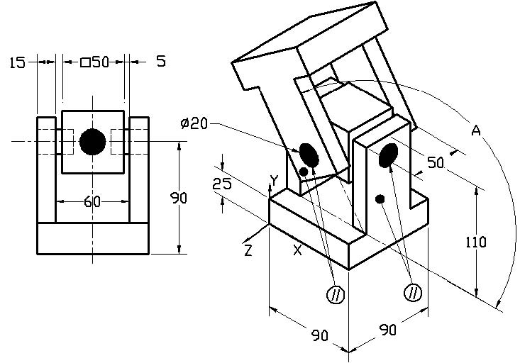
A = 16
B = 40
C = 16

