University of Jijel
Faculty of social and human sciences
Department of information and communication sciences
Level: 1st Year M/PEP
First semester Exam of English

Full name:
Group:

Questions:
- True or False:
- Print journalism is considered a more traditional form of media.
- Electronic journalism encompasses television, radio, and the internet.
- Newspapers are a common example of print journalism.
- Broadcast news (television and radio) relies heavily on visual and auditory elements.
- Print journalism is generally considered more credible than online journalism.
- Online journalism often includes interactive elements such as polls, comments, and live streams.
- Both print and electronic journalism face challenges in maintaining audience engagement in the digital age.
- Accuracy and fairness are essential ethical principles in all forms of journalism.
- The rise of social media has significantly impacted the way news is consumed and disseminated.
- Virtual reality (VR) and augmented reality (AR) may play a role in the future of journalism.

- Complete the missing information from 1 to 9
- 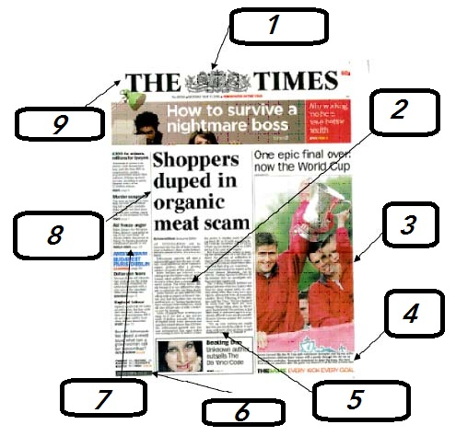

1: ………………………………………………………………………
2: ………………………………………………………………………
3: ………………………………………………………………………
4: ………………………………………………………………………
5: ………………………………………………………………………
6: ………………………………………………………………………
7: ………………………………………………………………………
8: ………………………………………………………………………
9: ………………………………………………………………………

Give an example of your own personal application that incorporates the nine previously mentioned components in the second
1: ………………………………………………………………………
2: ………………………………………………………………………
3: ………………………………………………………………………
4: ………………………………………………………………………
5: ………………………………………………………………………
6: ………………………………………………………………………
7: ………………………………………………………………………
8: ………………………………………………………………………
9: ………………………………………………………………………

Send the response in word folder via email: 1masterpress@gmail.com

NB: The deadline for submitting the work is Thursday, December 19th, 2024, at 17:00 PM.

Good luck

