Exercise 01: Complete the puzzle with learning styles using the clues below.
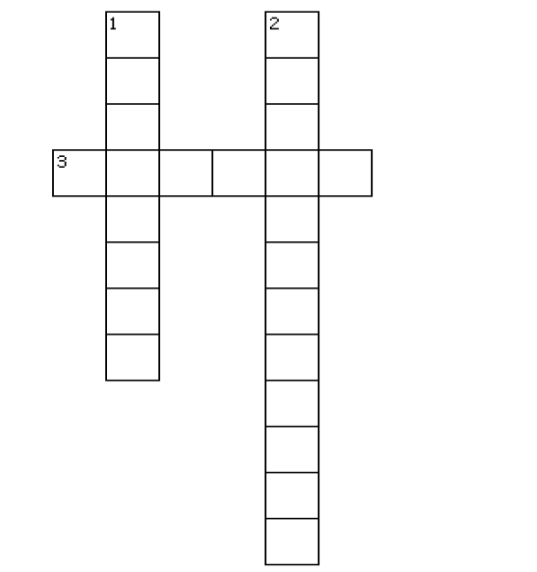
Across
3. A learner who finds it easier to learn when they can see things written down or in a picture. This type of learner may like the teacher to write a new word on the board and not just say it aloud.
Down
1. A learner who remembers things more easily when they hear them spoken. This type of learner may like the teacher to say a new word aloud and not just write it on the board.
2. A learner who learns more easily by doing things physically. This type of learner may like to move around or move objects while learning.



VAK Learning Style Questionnaire

Exercise 02: What is your preferred Learning Style? (What kind of learner are you?)
For each of the following questions, chose and circle the answer that describes you best.

1. When spelling a word, do you
- hear or say the word to yourself?
- see the word?
- write the word out to see how it feels?

2. When you remember things, do you
- see some moving images?
- see clear colour pictures?
- hear the sounds first?

3. When you are thinking hard, what interrupts you most?
- Untidiness
- Movement
- Noise
4. When you forget someone or something, do you
- forget the face but remember the name?
- remember where you were and what you were doing?
- forget the name but remember the face?

5. When reading, do you
- imagine the characters moving?
- make your own mental pictures?
- hear the characters talking?

6. When you relax, do you
- play sports or games?
- watch TV or read?
- listen to music?

7. Which do you prefer to help you learn
- to be active in doing things?
- written work with lots of colours?
- to be told things?
8. When talking, do you
- like to listen and talk?
- move your hands about as you talk?
- not want to listen for too long?

9. Which do you prefer as a reward?
- To be given a pat on the back.
- To hear it said to you.
- To get a written note.

N.B: Check your answers. If your answers are mostly A, you are an Auditory Learner. If your answers are mostly V, you are a Visual Learner. If your answers are mostly K, you are a Kinaesthetic Learner.

Exercise 03: What are the learning strategies you could suggest to improve the following areas?

1. Dealing with words in texts and recordings that you don’t know
2. Remembering new vocabulary
3. Learning new grammar
4. Improving pronunciation
5. Developing oral fluency
6. Developing comprehension skills
7. Becoming more independent

Answers’ Sheet

Exercise 01:
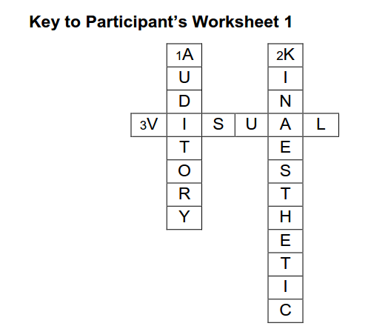

Exercise 02:
VAK Learning Style Questionnaire: key

Check your answers. If your answers are mostly A, you are an Auditory Learner. If your answers are mostly V, you are a Visual Learner. If your answers are mostly K, you are a Kinaesthetic Learner.

1. When spelling a word, do you
- hear or say the word to yourself? A
- see the word? V
- write the word out to see how it feels? K

2. When you remember things, do you
- see some moving images? K
- see clear colour pictures? V
- hear the sounds first? A

3. When you are thinking hard, what interrupts you most?
- Untidiness V
- Movement K
- Noise A
4. When you forget someone or something, do you
- forget the face but remember the name? A
- remember where you were and what you were doing? K
- forget the name but remember the face? V

5. When reading, do you
- imagine the characters moving? K
- make your own mental pictures? V
- hear the characters talking? A

6. When you relax, do you
- play sports or games? K
- watch TV or read? V
- listen to music? A

7. Which do you prefer to help you learn
- to be active in doing things? K
- written work with lots of colours? V
- to be told things? A

8. When talking, do you
- like to listen and talk? A
- move your hands about as you talk? K
- not want to listen for too long? V

9. Which do you prefer as a reward?
- To be given a pat on the back. K
- To hear it said to you. A
- To get a written note. V

Exercise 03: (Some suggested strategies)

- Guessing the meaning from context, looking words up in the dictionary, writing words down to ask someone about later.

- Saying new words in your head over and over again, writing new words down in your note book, writing new words down with a translation in your own language next to them, writing words down on separate cards and storing them in a box.

- Practising the language as soon as you’ve learnt it, repeating different examples of the language, writing down the different grammatical components of the language, cutting up the different components and arranging them in the correct order.

- Learning the sounds and symbols in the phonemic chart, asking teachers and other students to correct your pronunciation, recording yourself and listening for pronunciation errors.

- Speaking English only in class, speaking English whenever possible outside class, practise speaking for one minute on a topic without hesitating.

- Reading more authentic material (magazines and newspapers etc.) outside class, listening to English radio/TV programs outside class, asking people to repeat what they have said when you don’t’ understand.

- Using the internet to research language and vocabulary, using English-English dictionaries to research vocabulary, choosing an area of language or vocabulary to revise/learn and using resources to self-study.

