The cinematic language – a semiological analysis of the film (Paradise now)

INTRODUCTION
Cinema is a mass medium communication and an effective means of expression that is created within sign systems/linguistic or visual signs through different contexts. Therefore, the cinematic language is special and different from other communication languages; it covers many approaches from several disciplines in order to understand the structure of textual and visual language in this art that can be considered as a pole of attraction.
Language in cinema embraces different systems of sings made up by a whole set of significant details. The study of cinematic language is basically related to the nature of signs in films and how they are organized through the relation between them that leads to signification as Roland Barthes stated in his book elements of semiology ‘the signification can be conceived as a process, it is the act which binds the signifier and the signified whose product is the sign’ (Roland Barthes 1968). The history of film theory refers to the idea of language that depends on film gramatical rules in order to be meaningful and significant for the audiences. Therefore, the language in cinema is like any other language; the more thoroughly you master it, the more you can communicate and convey meanings effectivly.

1 Cinematic Language
Cinematic language. You will have most likely heard this phrase being used in film circles, about a screenplay or in reference to a film or TV episode. But what is cinematic language?
Cinematic language is the methods and conventions of cinema that are used to communicate with the audience. This is often also referred to as visual storytelling, although this is only one part of cinematic language. Emotions and ideas are expressed in cinema visually through all types of techniques such as lighting, performance, mise-en-scéne, cinematography, editing and more (industrial scripts, 2021)
2 What is a sign?

Within the rise of linguistics, semiotics became an important field that studies the life of signs within society. Roland Barthes analyzed the signs within two main semiotic concepts: the signified and the signifier from the Saussurean perspective as shown in the following drawing:
sign

signifier signified

3/ signification defined
Roland Barthes, who first set up a systematic model by which this negotiating, interactive idea of meaning could be analysed. At the heart of Barthes’s theory is the idea of two orders of
Signification (John Fiske, 1990) which is devided into two levels :
- Denotation
The first order of signification is the one on which Saussure worked. It describes the relationship between the signifier and signified within the sign, and of the sign with its referent in external reality. Barthes refers to this order as denotation.

- Connotation

Barthes contends that the author can no longer be regarded as the omniscient and holds the total authority and influence in the text. He considers the reader to become as the premier source of power in a work of literature. According to him ‘the birth of the reader must be at the cost of the death of the author’ (J.A Cuddon 1998)
In cinema the film is open for interpretations of the audience who is oriented by different contexts ( social, cultural, religious, political...etc)

4/Elements of the cinematic language

4.1 plot and story
There is a difference between the story and the plot in the narative. Think of any feature film you know well, it probably does not relate the whole story to the audience in chronological order but leaves the audience without certain pieces of information at some points in the narrative some characters know things which other characters do not know. Both audience and characters become involved in making sense of the events and information in the order in which they are given, this method of organizing events is called plotting (Brenda Downs and Steve Miller, 1998)
4.2 Narration
Narration is the job of the narrator who tells, and mediates the events for the audience. The narrator has an important role in understanding the events and the plot of the films.
4.3 characters : A character is a person, animal, being, creature, or thing in a story. Writers use characters to perform the actions and speak dialogue, moving the story along a plot line. A story can have only one character (protagonist) and still be a complete story. This character’s conflict may be an inner one (within him/herself), or a conflict with something natural, such as climbing a mountain. Most stories have multiple characters interacting, with one of them as the antagonist, causing a conflict for the protagonist.
4.4 screen time
In cinema, events do not take place in real time, but it makes sense of what we see in an average time of 90 minutes, the audience lives different events in the past, present and future.
4.5 Onscreen space
Cinema as a part of media narratives is located somewhere, it may take place in many locations; outside ( in the streets, cities, nature) and inside ( houses, studios, firms, institutions…) or in fictional locations that new technologies and artificial intelligence offer for filmmakers.
4-6 Light
The light gives the audience information about time, day or night, the season, the weather, and whether the characters are inside or outside, light also can give the audience clues to characters which offer insights into people, places, and things within the frame

4-7 Shots
A camera shot is composed of the series of frames that are shot uninterrupted from the moment the camera starts rolling until it stops. Camera shots are an essential aspect of filmmaking and video productions, because by combining different types of shots, angles and camera movements, the filmmakers are able to emphasize specific emotions, ideas and movement for each scene. There are several types of camera shots :

Extreme Long Shot

An extreme long shot (or extreme wide shot) make your subject appear small against their location. You can use an extreme long shot to make your subject feel distant or unfamiliar.

Long shot
The long shot (also known as a wide shot) is the same idea, but a bit closer. If your subject is a person then his or her whole body will be in view but not filling the shot.

Full shots

full shots can be used to feature multiple characters in a single shot.

Medium wide shot

A medium long shot (aka medium long shot) frames the subject from roughly the knees up. It splits the difference between a full shot and a medium shot

Medium shot

The medium shot is one of the most common camera shots, it emphasizes more of your subject while keeping their surroundings visible.

Medium close up shot

The medium close-up frames your subject from roughly the chest up. So it typically favors the face, but still keeps the subject somewhat distant.

The close up shot

The close-up camera shot fills your frame with a part of your subject. If your subject is a person, it is often their face (studiobinder, 2020)

5- Methodology of the research

Semiology is the most appropriate method to study visual communication like films, and the observation as a tool of collecting data.

We will analyze the film of (Paradise now) using semiology as a method .

The semiology analysis of the film Paradise now

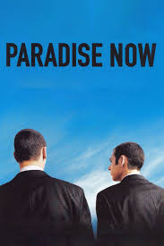
Photogram n : 01

One/ The language of the title

Paradise now, is a phrase that is opened for many interpretations according to the cultural, political, social and religious contexts, which related to the Islamic culture through the concept of Jihad, which is widely misunderstood in the west. The two friends prepare for a martyredom operation to seek the Paradise which is the home of those Allah has blessed.
Two/ Denotation level
The two characters wear classic black suits, appearing during the day where the blue sky is visible. The shot was taken fromthe back.
The second photogram, The image shows two Palestinian men; the man on the right is preparing for martyrdom operation with a suicide belt, while the second man on the left is holding a paper, and wearing kufiyeh. The palestinian flag is drawn on the wall and som arabic writing appear in this shot.

a/ The language of characters :

khaled and Said are two friends who will make the martyredom attack in Tel Aviv, the two characters presents courage, patriotism, faith, unity, and freedom which has no price, they are ready to die for free Palestine after long years of occupation and oppression againt the original citizens of Palestine.
Said and Khaled were attached with explosive best for each one, the men believe that Palestinians have the right to live and deserve their liberty.

The image in this films tells the story of oppresed people for long years , the story of courageous people who don’t fear to die, because they know the real life which is Paradise, for them death is paradise now, thus, the perspective of death is different here.

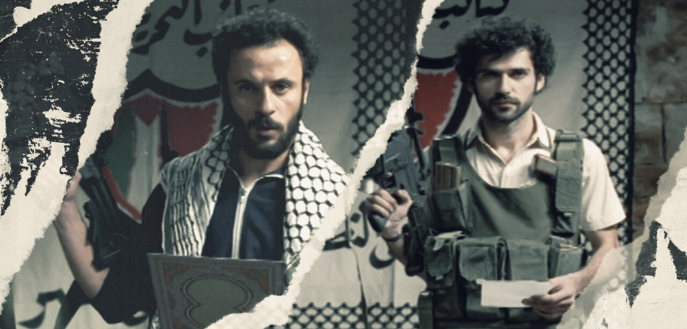
Photogram n :2
b/ The language of colors

The main colors in this film are the white and the black that appeared in the clothes of Saidand Khaled

- The white color symbolizes purity, freedom, peace,
- The black symbolizes death, satire, but also confidence and power
- Red :represents fear, death, blood

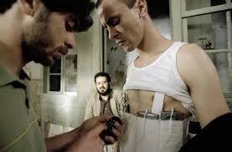
Photogram : n 03

Photogram :n04

c/ The language of music

The music used in this film was full of nostalgia, that exprsses the general facts that refer to martyredom operation and reflect the situation of the two friend Said and Khaled who live in Nablus.
d/ Onscreen space
photogram 01 is located somewhere, outside where the sky is shown as a part of nature and reflects horizons , ambitions and may freedom.
Photogram n 2 is located in the streets of Nablus that symbolize resistance and Jihad, through the symbolic writings on the walls.
Photogram n :3 shows a poor house that witness the martyrdom operation of the two friends.

e/light : the light in the &st photogram represents the day which is natural light, through the blue sky, however in the 2nd and the 3rd photograms the light is artificial and the shots were taken in the house.

