University of Mohamed Sediq Ben Yahia
Faculty of haman and social sciences
Department of comunication and infoemation sciences
Master 01 audiovisual
Name :
Email : studies.univ18@gmail.com
The mark :
Dedline :30/04/2025
Exam of english language
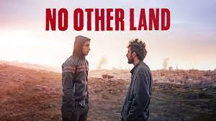
image n :01

image n :02
Exercise n :01/n
No Other Land is a 2024 documentary film directed by Basel Adra, Hamdan Ballal, Yuval Abraham and Rachel Szor in their directorial debut. A Palestinian-Israeli collective of four activists conceived and produced the film in what they describe as an act of resistance on the path to justice in the Israeli–Palestinian conflict.
- Give suitable interpretations to the title of this documentary film (No Other Land)
- What is the appropriate method used to study the image ?
- What is the tool of this study ?
- What is the importance of the non-verbal language in this documentary.
- What are the two levels of signification in these images , in which you explain the different elements of the cinematic language ?
- Explain to what extent these images are rhetoric.

Good luck
Dr. Bouzida

