University of Jijel
Faculty of social and human sciences
Department of information and communication sciences
Level: 1st Year M/PEP
Second semester Exam of English

Full name:
Group:

Questions:
- Based on what has been studied in the web writing and design lesson, what are the most important remarks you would offer for this page?
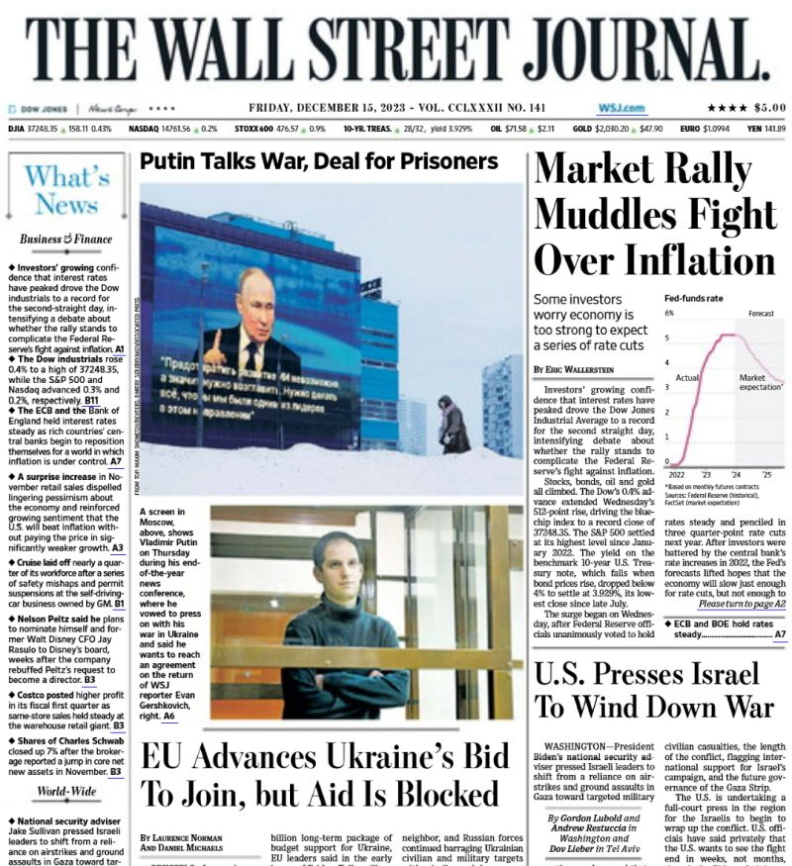

- Provide technical and editorial suggestions to improve the presentation of this page, (the suggestion should be in the form of a written paragraph, along with an accompanying image that explains it).

Send the response in word folder via email: 1masterpress@gmail.com

NB: The deadline for submitting the work is Thursday, May 1st, 2025, at 17:00 PM.

Good luck

